**Knowledge Representation and Cognitive Psychology**

**Notes and Concepts:** *by Andrew Gold (2016)*

**______ =** Terms (and the definitions) to understand

**_____ =** Chemicals, substances, and other biological factors/processes to understand

**______ =** Concepts to understand (can contain subcategories, must know everything contained!)

**Lecture 1 – the Nervous System:**

***Reading: KRCP textbook pages 37-60***

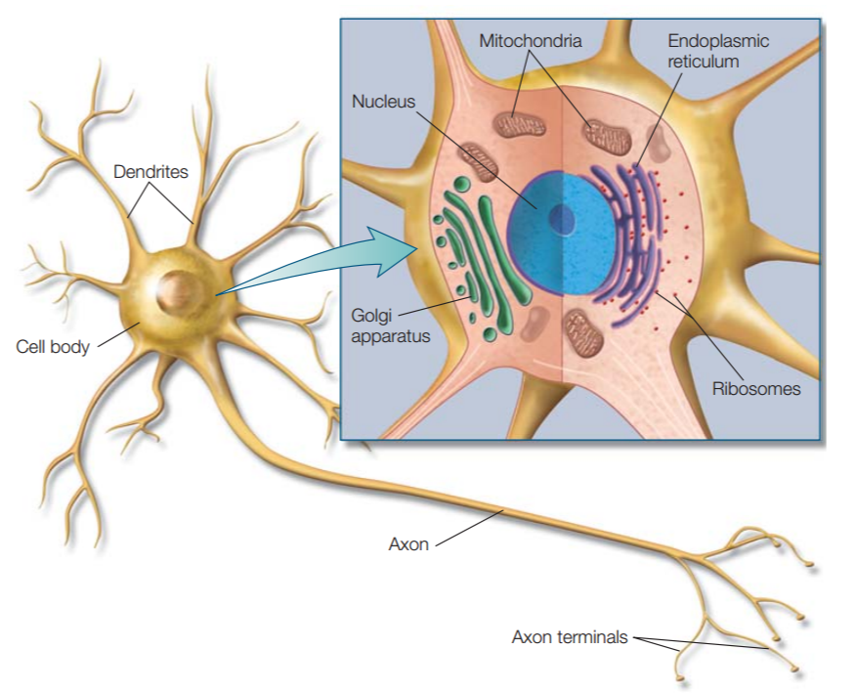

**Nervous System:**

**Neurons (100 Billion, 10^11):** Neurons are the basic signaling units that transmit information throughout the Nervous System. Neurons vary in form, interconnectivity, and location, and these variances are closely related to their function.

* **Glial Cells (1 trillion, 10^12):** are nonneural cells that serve various functions in the nervous system, and are still not fully understood.
  + - * *Provide structural support*
      * *Create electrical insulation to the Neurons (Myelin)*
      * *Modulate Neuronal activity*
  + **Astrocytes:** Star-shaped Glial Cells that provide nutrients at the cellular level, as well as provide biochemical support/maintenance of the blood-brain barrier structures.
  + **Oligodendrocytes**: Cells that perform Myelination of the Neuron.
  + **Schwann Cells:** The primary Glia of the Peripheral Nervous System. Perform the same function of the Oligodendrocytes and Astrocytes, providing the Myelin Sheath as well as general maintenance to the nerves of the PNS.
* **Cell Body (Soma):** Contains the machinery that produces proteins and other cellular macromolecules. Contains a ***Nucleus, Endoplasmic Reticulum, Cytoskeleton, Mitochondria, Golgi apparatus, other common intracellular organelles.*** These structures are suspended in ***Cytoplasm***, the salty intracellular fluid made up of a combination of ions from ***Potassium, Sodium, Chloride, and Calcium.***
  + - **Dentrites:** Branching extensions of the Neuron that ***receives input*** from other neurons.
      * *Many dendrites contain “****spines,”*** *or small knobs where dendrites receive input from other neurons.*
    - **Axon:** A single ***output structure*** that extends from the **AXON HILLOCK** at the base of the cell Soma, away from the cell body. Electrical signals travel down the axon toward the **AXON TERMINALS**where the neuron transmits the signal to other neurons or other cell types (***via DENDRITES and other AXONS***).
      * **Axon Hillock:** The **AXON HILLOCK** is a specialized part of the cell body that is the connection to the axon. The hillock is the last site in the cell body where membrane potentials propagated from synaptic inputs are summated before being transmitted to the **axon**.
      * **Myelin:** a fatty insulation substance that protects the axon from “losing information” in transit. There are regularly spaced gaps in the myelin called **NODES OF RANVIER*.***
    - **Synapses (10^15 synapses, ~10k per neuron)**: Transmissions occur at the synapse, where two neurons come into close contact so that ***electrical*** **or** ***chemical signals*** can be passed from one cell to the next.

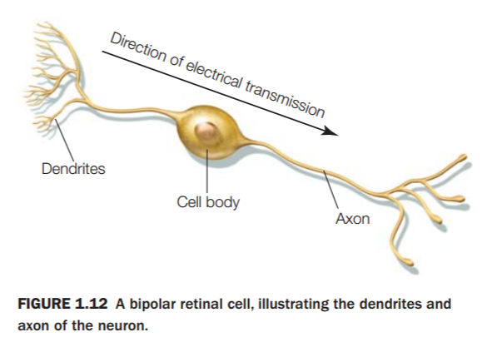

**Central Nervous System:** The brain, brain stem, and spinal cord. The job of the CNS is mostly focused in the brain and spinal cord, where all cognitive and subconscious thought occurs. The brain processes information received from the Peripheral Nervous System (PNS), as well as relaying information to the PNS for implementation. The main conduit of the CNS is the spinal cord.

**Peripheral Nervous System:** The nerves and ganglia that exist outside of the brain and spinal cord. The main job of the PNS is to relay information transmitted by the brain throughout the body, and to gather input from the body and relay it back to the brain via the spinal cord.

* + - **Somatic (Voluntary Control):** The Somatic Nervous System oversees voluntary control of the skeletomuscular system. This includes bodily movements of the muscles, skin, and bones.
    - **Autonomic (Involuntary Control):** The Autonomic Nervous System oversees the involuntary controls of the body, such as breathing, digestion, operation and function of the organs, and involuntary movements of smooth muscles.

**Neuroanatomy:**

* **Scales of Analysis:**
  + **Macroscale:** the human brain as a whole, or the divisions into the long-range associations between individual regions.
    - Lobes, Hemispheres, white/grey matter, Brodmann’s areas
    - **Brodmann’s areas:**
      * Touch (1, 2, 3)
      * Vision (17)
      * Hearing (41)

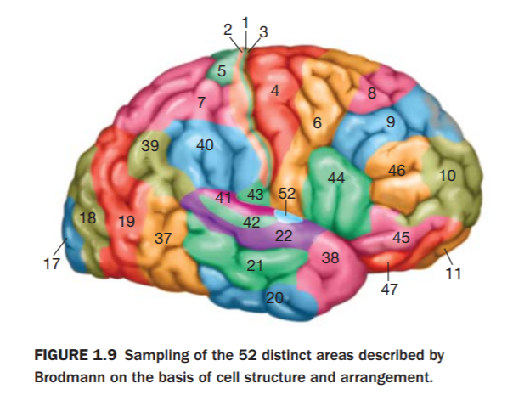

* + **Mesoscale:** the subdivisions of individual regions in the brain, such as the circuits of the brain.
    - **Circuits:** The brain’s circuitry is still a partial mystery, as the relationship between subdivisions of the brain is difficult to monitor. But we know that most subdivisions of the brain (See Brodmann’s areas above) communicate with each other, and are interdependent upon each other’s function.
    - **Cortical columns:**
      * Cortical columns are subdivisions of the cortex, where “hypercolumns” are composed of about 50-100 “microcolumns.” Neurons within a specific column encode similar features, and are separate from the columns surrounding them. More research is needed to fully understand their role.
      * Microcircuits within the Cerebral Cortex perform their own independent functions.
    - **Cortical Layers:**
      * + **1, 2, 3** – Integrative Functions
        + **4** – Input of Sensory Information
        + **5, 6** – Output to other parts of brain.
  + **Microscale:** The microscopic parts that make up the brain.
    - **Neurons** :
      * Axons, Axon Hillock, Synapses, Cell Soma
    - **Glia:**
      * Astrocytes, Oligodendrocytes, Schann Cells, Microglia
  + **Nanoscale:** the synaptic level, where the electrical and chemical actions of the brain take place.
    - * Synapses
      * Neurotransmitters
        + Chemicals of each type of Neurotransmitter
* **Planes:**
  + **Saggital:** Left/right plane (when facing from front/back)
  + **Coronal:** Front/back plane (when facing from front/back)
  + **Transverse/Axial/Horizontal:** Bottom/top plane (When facing front/back)
* **Directions: (From the human perspective)**
  + **Superior/Dorsal:** Top part of the brain.
  + **Inferior/Ventral:** Bottom part of the brain.
  + **Anterior/Rostral:** Front side of the brain
  + **Posterior/Caudal:** Back side of the brain.
  + **Medial:** The Medial Line is the line down the middle, from front to back, of the brain.
  + **Lateral:** The Lateral side(s) are the sides of the brain (human perspective).

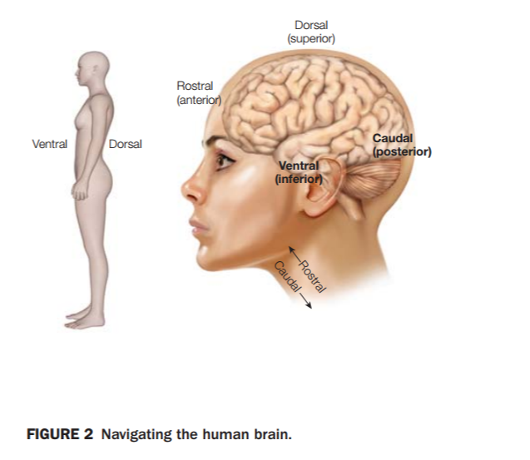 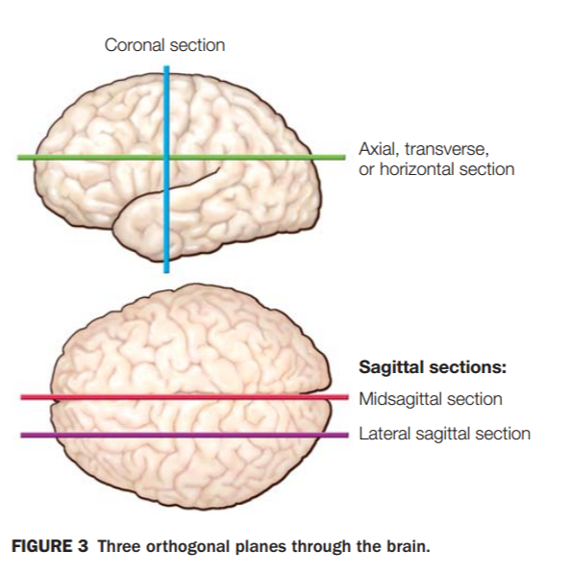

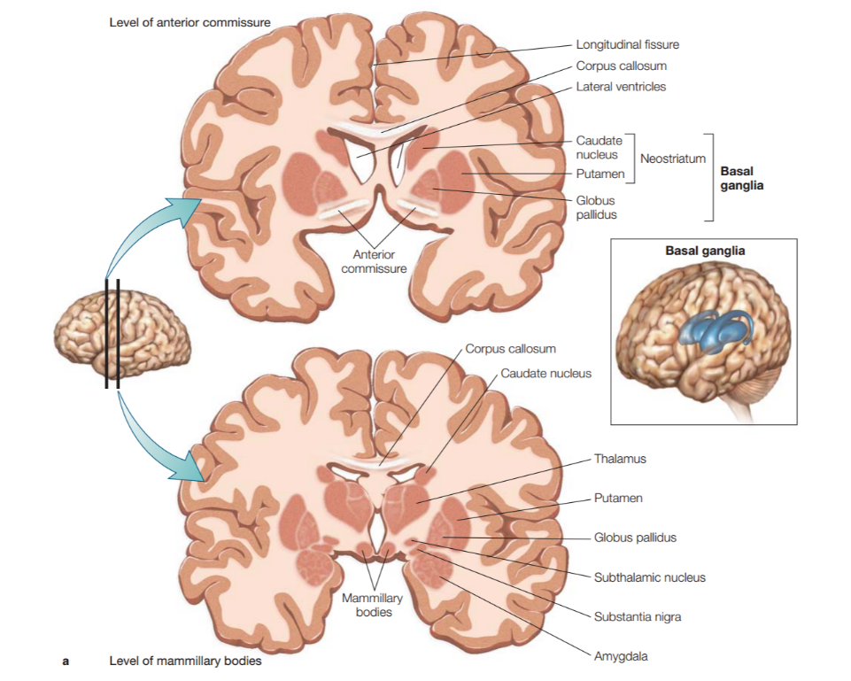

* **White Matter:** Made up mostly of **MYELINATED** axons (and other information transmitters) that are the “information highways” of the brain.
* **Grey Matter:** Cell bodies and usually **UN-MYELINATED** axons.
* **Hemispheres:** There exist two hemispheres of the brain, divided evenly down the ***medial line*** that separate the brain into “Left” and “Right” hemispheres.
* **Ventricles:** Ventricles produce Cerebrospinal Fluid (CSF) which acts as a cushion, or buffer, between the Cerebral Cortex and the inside of the skull. CSF also plays a large roll in blood flow throughout the brain, and cerebral autoregulation.
* **Brain Stem:** Provides the main motor and sensory input to the face and neck. Additionally, all the motor and sensory nerves from the brain pass through the brain stem to the rest of the body. The brain stem regulates the Central Nervous System.
  + **Hindbrain:** Supports vital bodily processes.
    - **Medula:** Basic functions (IE respiration, heart rate)
    - **Cerebellum:** Motor and cognitive functions
    - **Pons:** Basic functions (IE digestion, sleeping)
  + **Midbrain:** The midbrain controls many autonomous and manual functions, such as the sleep/wake cycle, vision, hearing, motor control, alertness, and temperature regulation.
  + **Diencephalon (Part of the Forebrain)**
    - **Thalamus:** Relay station of the brain. Processes input, and distributes it to the relevant centers in the brain.
    - **Hypothalamus:** Hormone and autonomic control, Nervous System control.
      * Regulates hunger, hormones, temperature, sleep, and other cycles.
  + **Telencephalon:** The embryonic structure (early development) from which the cerebral cortex develops.
    - **Limbic System:** Memory and Emotions
      * Frontal Cortex, Fornix, Cingulate Cortex, Corpus Collosum, Thalamus, Stria Terminalis, Hippocampus, Amygdala, Mammillary Body, Olfactory Bulb, Septum, (Basal Ganglia)
    - **Basal Ganglia:** Group of structures in the Thalamus overseeing motor control and motor learning processes.

***Cerebral Cortex:*** *The Cerebral Cortex is the outermost layer of matter on the brain, made up of* ***neural tissue,*** *that plays the role in* ***MEMORY, ATTENTION, PERCEPTION, AWARENESS, THOUGHT, LANGUAGE, AND CONSCIOUSNESS.*** The human CC is 2-4mm thick.

* + **Gyri:** “**Bumps” on the brain surface.**
  + **Sulci:** **“Grooves” on the brain surface.**
  + **Cortical Layers:** There exist 6 layers of the cerebral cortex, where each layer has a different cell density, along with separate functions for each.
  + **Brodmann’s Areas:** Histological classifications.
* **Lobes and their functions:** Each lobe of the Cerebral Cortex plays a different role in the overall function.
  + **Frontal Lobe:** Motor function, planning, language production, personality.
  + **Temporal Lobe:** “What” pathway, auditory cortex, language perception, memory.
  + **Occipital Lobe:** *Exclusively reserved for visual processing.*
  + **Parietal Lobe:** Attention, Sensorimotor(), High-Order vision, Somatosensory Cortex()
    - **Sensorimotor:** Control, body position, and voluntary movements.
    - **Somatosensory Cortex:** Sensory cortex that responds to changes of internal state within the body.

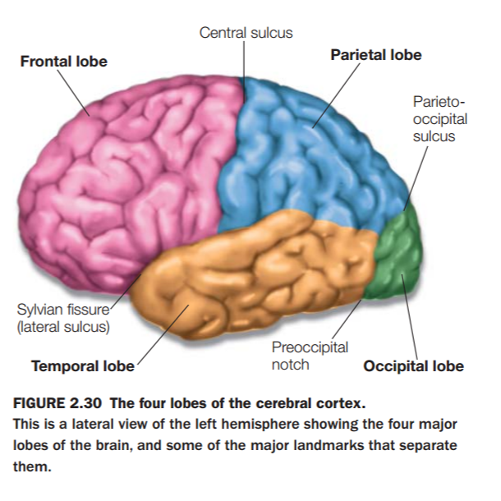

**TAKE HOME MESSAGES:**

* **Neurons:**
  + Neurons and glial cells make up the nervous system
  + Neurons are the cells that transmit information throughout the nervous system. Most neurons consist of a cell soma (body), axon, and dendrites.
  + There are important ways of “slicing” the brain:
    - Coronal goes through the center of the brain, ear-to-ear. It allows you to see the front or back portion of the brain.
    - Sagittal goes from front-to-back, down the center of the brain. Imagine slicing your nose in half down the middle. It allows you to see the left or right hemispheres.
    - Axial/Transverse/Horizonal slice is just that – a horizontal slice of the brain. It allows you to see the top and bottom of the brain.
  + There are important directions when regarding to the brain’s sections:
    - Superior/Dorsal: the top part of the brain (think superiority sits at the top)
    - Inferior/Ventral: the bottom part of the brain (think inferiority belongs at the bottom)
    - Anterior/Rostral: Front part of the brain (behind the face)
    - Posterior/Caudal: Back part of the brain, at the rear of the skull
  + There are important subsections of the brain:
    - White Matter: contains the bundles of MYELINATED AXONS within the brain, where most of the information relay takes place.
    - Grey Matter: contains cell bodies and generally UNMYELINATED AXONS.
    - Ventricles: Contains Cerebrospinal Fluid, which acts as a cushion for the brain and plays important roles in maintaining brain function via the blood-brain barrier.
    - Brain stem: The base of the brain, acts as the “channel” to the rest of the body. Also responsible for sending signals to the face and neck.
      * Medulla: (caudally located) contains sensory and motor nerves for the face, neck, abdomen, and throat.
      * Pons: the “bridge” between the brain and cerebellum, passing along facial and eye movements.
      * Cerebellum: Integrates all movement information within the brain, allows for highly coordinated movements.
      * Midbrain: Helps with peripheral vision and coordinating directional movement.

**Lecture 2: Nervous System cont…**

***Reading: Chapter 2 – structure/functions of the nervous system (22-37)***

**Neurotransmission Processes:**

* **Neuron Resting Potential:** Neurons are unlike other cells in the body, as they are “excitable,” meaning they can change the permeability of their membranes.
  + **Cell Membrane:** The neuron’s cell membrane is the “outer layer” of the cell. Resting potentiality arises from the asymmetric distribution of the ions Sodium (Na+), Potassium (K+), Chloride (Cl-), and charged protein molecules (A-) across the surface of the cell membrane. The lipid membrane maintains the separation of intercellular and extracellular ions and electrical charge that ultimately permits neuronal communication.
  + **Intracellular:** “Inside the cell” (usually refers to ions and electrical charge)
  + **Extracellular:** “Outside the cell” (usually refers to ions and electrical charge)
  + **Membrane Resting Potential:** The “resting membrane potential” is the voltage difference across the neuronal membrane, between the intra/extracellular spaces. This averages to be ~70mV +/-
  + **Ion Concentrations at rest (intra & extracellular)**
    - **Sodium (Na+):** The sodium ion is one of the common ions found in CSF, neurons, and throughout the greater nervous system.
    - **Chloride (Cl-):** Chloride is also a common ion found in CSF and throughout the nervous system.
    - **Potassium (K+):** Potassium is also a common ion found in CSF and throughout the nervous system.
    - **Negatively charged proteins (A):** Negatively charged proteins that are capable of permeating the neuronal cell membrane.
  + **Entropy/Concentration pressure (gradient):** the measure of pressure/force between the membrane, allowing an uneven distribution of ions to arise (leading to potentiality).
  + **Electrostatic Pressure:** Ions of identical charge *repel* each other. This leads to electrostatic pressure across the cell membrane, AKA ***electrical potential.***
  + **Equilibrium/Reversal Potential:**
  + **Ion Channels:**
    - **Voltage gated Ion channels:** Ion channels are trans-membrane channels that allow the flow of ions from inside the cell to outside, and vice versa. These 3-dimensional structures ***selectively*** permit **one** type of ion to pass through the membrane.
      * **Select:** Sodium, Potassium, Chloride, or Calcium ions.
    - **Passive Ion Channels:** these channels are always open, and allow the slow transfer of ions into and out of the neuron.
  + **Na/K pumps:** The sodium/potassium pump is an ion pump that specifically targets sodium and potassium. The Na/K pump *actively pumps* 3 Sodium (Na) ions out of the cell, and allows 2 Potassium (K) cells in. This results in an imbalance, and sodium tends to re-enter the cell via the sodium ion channel, leading to a negative charge within the cell.

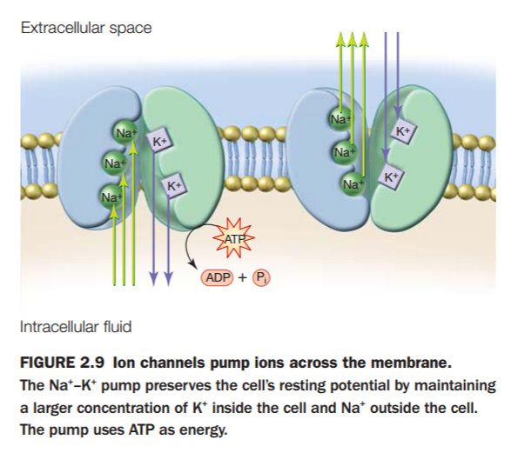

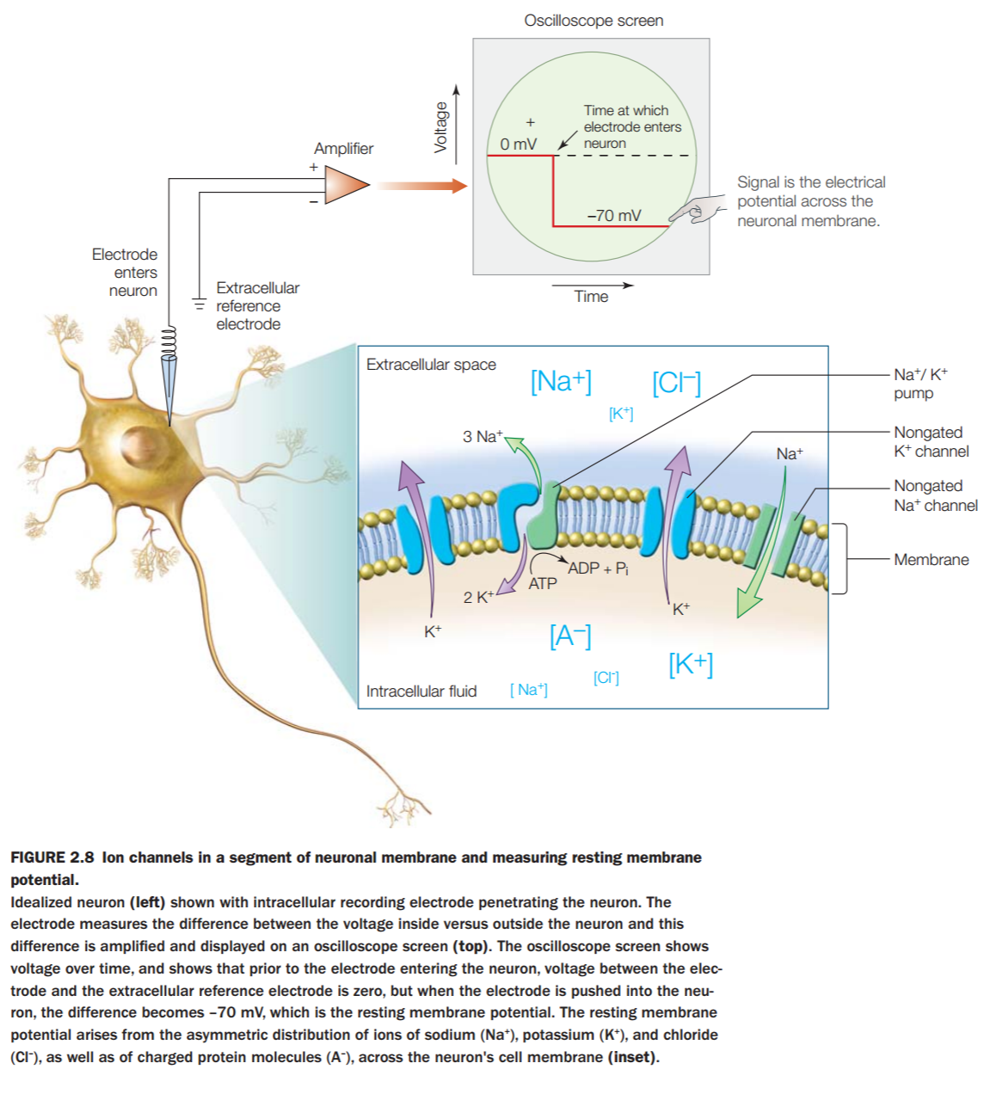

* **Graded post-synaptic potentials:** Grading means that they have an additive effect. When enough multiple EPSP’s occur on a single patch of membrane, they trigger an **ACTION POTENTIAL.** IPSP’s, in contrast, can prevent an **ACTION POTENTIAL** from occurring, and the more IPSPs that occur, the less likely an **AP** will occur.
  + **EPSP (Excitatory post-synaptic potential):** a post-synaptic potential that *results from the flow of positive ions into the cell*, leading to the increased likelihood of the firing of an action potential.
  + **IPSP (Inhibitory post-synaptic potential):** The exact opposite of EPSP. They can take place at all chemical synapses. Inhibitory presynaptic neurons release neurotransmitters that then bind to the postsynaptic receptors; this induces a postsynaptic conductance change as ion channels open or close. An electric current that changes the postsynaptic membrane potential to create a more negative [postsynaptic potential](https://en.wikipedia.org/wiki/Postsynaptic_potential) is generated.
  + **Temporal Summation:** the summation of chemical or electrical potentiality from within a single neuron **over time.**
  + **Spatial Summation:** the summation of chemical or electrical potentiality from multiple neighboring neurons.

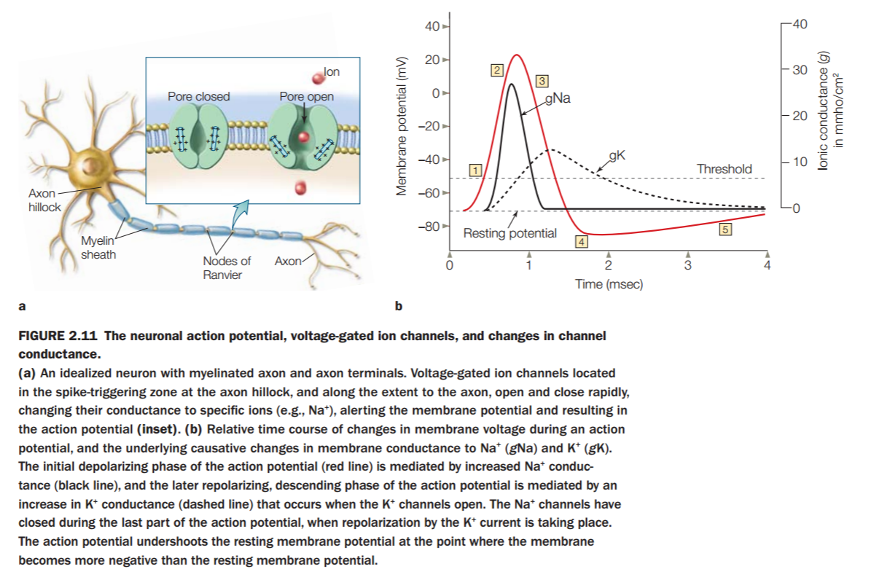

* **Action Potential: (AP)**
  + **Threshold potential:** The threshold required to fire an action potential, summated by chemical or electrical potentiality. It rests somewhere around -55 milliVolts.
  + **Order of ion channels opening and closing:**
    - **Na+:** When an **AP** is reached, sodium flows rapidly into the neuron. This leads to further instability inside the neuron, allowing even more voltage-gated **SODIUM** ion channels to open. This lasts only about 1 millisecond.
    - **K+:** Once the sodium ion channels close, the potassium channels open and release potassium out of the neuron and down its ***CONCENTRATION GRADIENT.*** This outward flow of ions takes longer (remember that potassium travels more freely through the membrane than sodium) and causes a second re-polarization phase of the AP, driving the membrane to the **EQUILLIBRIUM POTENTIAL** of K+, which is even more negative than the resting potential. (About -80mV)
      * This results in **HYPERPOLARIZATION,** which prevents Na+ gates from opening, and allows the inner neuron to eventually settle back into its resting potential. (about -70mV)
  + **Direction and times of ion flows:** Na+ goes in first (fast, ~1ms), K+ goes out second (slower, >1ms)
  + **Refractory period:** The period where **HYPERPOLARIZATION** occurs.
    - **Absolute:** disallows any further **APs** from occurring.
    - **Relative:** after the absolute refractory period, allows **APs** but only ones caused by larger-than-normal depolarizing currents.
  + **Propagation:** the “spreading” of electrical signals throughout the nervous system.
    - **Myelination:** Myelin is a fatty substance that insulates the **AXON.** Signals propagated by myelinated axons travel faster and further than those without the myelin sheath.
    - **Nodes of Ranvier:** The spaces between myelin sheaths where Na+ and K+ channels are located, and action potentials occur.
    - **Saltatory Conduction:** (Latin for “jump”) The action potentials of myelinated sections of the axon do not need to occur as often as an unmyelinated axon. Therefore, when an **AP** is generated at a **NODE OF RANVIER**, the signal “jumps” down the sheath to the next **NODE OF RANVIER**.
* **Synapses:** A neuron communicates with other neurons, muscles, or glands at a **SYNAPSE**, and the transfer of a signal from the axon terminal to the next cell is called synaptic transmission. There are two major kinds of synapses — chemical and electrical, each using very different mechanisms for synaptic transmission.
  + **Synaptic Transmission:** The mechanism works as such. An **AP** occurs, reaches the end of the **Axon terminal**, leading to the depolarization of the **TERMINAL MEMBRANE,** Causing voltage-gated Ca2+ channels to open. The opening of these channels causes electrostatic pressure to force **VESICLES** (below) containing neurotransmitters (below) to fuse with the presynaptic cell membrane, releasing the transmitter into the ***SYNAPTIC CLEFT.***
  + **Electrical (sometimes):**
  + **Chemical (mostly):** Most neurons transmit signals by releasing ***NEUROTRANSMITTERS*** into the ***SYNAPTIC CLEFT***. The transmitter diffuses, or scatters, across the membrane, and upon reaching the **POST-SYNAPTIC MEMBRANE**, binds with transmitter-specific receptors embedded in this post-synaptic membrane.
    - This induces a change in the receptor, leading to the opening of ion channels that leads to EPSP or IPSP of the **POST-SYNAPTIC CELL.**
  + **Pre-synaptic:** The neuron that transmits the neurotransmitter generates the neurotransmitter, and stores it in the pre-synaptic terminal.
  + **Post-synaptic:** The neuron on the receiving end contains receptors, and depending on the received neurotransmitter, elicits a response.
  + **Ca2+:** Action potentials cause calcium ions to depolarize the terminal.
  + **Synaptic Vesicles:** Stores various neurotransmitters that are released at the **synapse**. The release is regulated by a voltage-dependent calcium channel.
    - **Vesicles** are essential for propagating nerve impulses between neurons and are constantly recreated by the cell.
  + **Exocytosis:** The transfer of a molecule (in this case, neurotransmitters) out of the cell via the vesicle.
  + **Synaptic Cleft:** The gap between neurons at synapses.
  + **Receptor:** A receptor in the cell’s (neuron’s) membrane, receiving chemical input such as from neurotransmitters.
    - **Ionotropic:** ion-channel receptors that accept the flow of neurotransmitters.
    - **Metabotropic:** indirectly linked to ionotropic receptors, these ***indirectly*** allow the flow of neurotransmitters, but by a secondary process of chemical messengers that eventually allow the flow of neurotransmitters.
* **Neurotransmitters:** (Amino acids, biogenic amines, neuropeptides)
  + **Small-molecule:** Single amino acids
    - **Acetycholine (Muscle):**  the chemical that [motor neurons](https://en.wikipedia.org/wiki/Motor_neuron) of the nervous system release to activate muscles.
    - **Monoamines:** involved in the regulation of cognitive processes such as emotion, arousal, and certain types of memory.
    - **Dopamine (Pleasure, Addiction):** The “reward” chemical. The release of dopamine “teaches” the brain that an activity or stimulus is beneficial. Overstimulation via dopamine can lead to addiction. An organic chemical amine that in the brain functions as a neurotransmitter. It is formed from L-DOPA by removing a carboxyl group.
    - **Serotonin (Sleep, Eating, Depression):** mediates gut movements and the perceptions of resource availability.
      * **Amino Acid:** a simple organic compound containing both a carboxyl (COOH) and an amino (NH2) group.
      * **Glutamate:** ***Primarily used in learning and memory***. The most abundant neurotransmitter in the NS, accounting for 90% of all synaptic transmissions.
        + **Main brain excitatory:** Glutamate stimulates the brain.
      * **GABA:** accounts for 90% of all inhibitions.
        + **Main brain inhibitory:** GABA, Serotonin, and other inhibitory neurotransmitters do NOT stimulate the brain. ***Provides a balance*** to the excitatory neurotransmitters.
    - **Neuropeptides:** Large neurotransmitters, made up of ***strings of amino acids.*** Divided into 5 groups (not important to study)
      * *Tachykinins*: (pain)
      * *Neurohypophyseal hormones*: (love, production of urine)
      * *Hypothalamic releasing hormones*: (Stress, growth inhibition)
      * *Opioid peptides*: (Endorphins, feel-good chemicals)
      * *Other*
    - **Gaseous:** Difficult to study, as they exist for only a few seconds. Believed to be used to stimulate the production of other “messenger chemicals.”

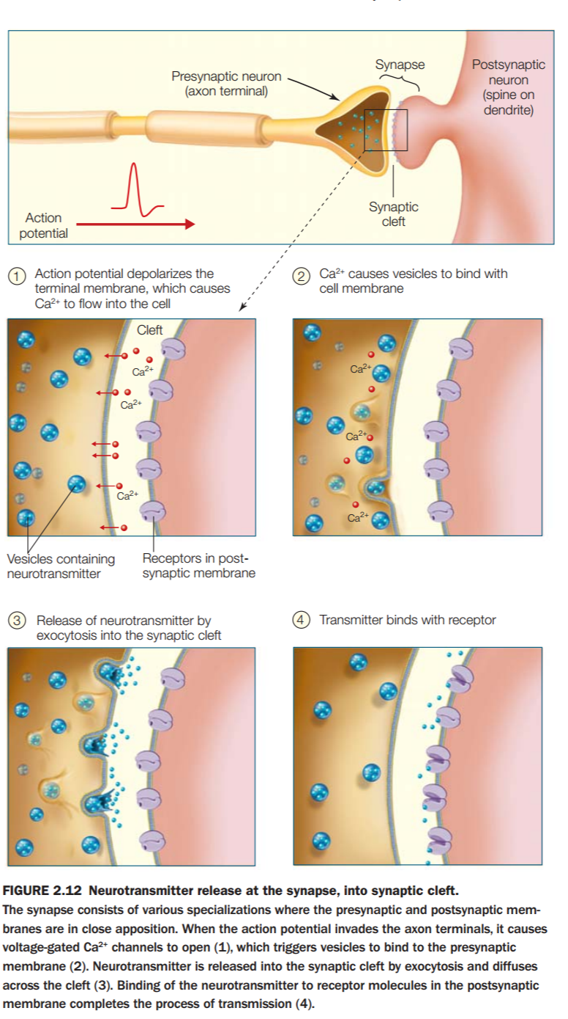

**TAKE HOME MESSAGES:**

* **Neuronal transmission:**
  + The presynaptic cell is located before the synapse (with respect to information flow) and the postsynaptic cell is located after the synapse (with same respect). Nearly all neurons are both pre-and postsynaptic, since they both receive and transmit information.
  + The resting membrane potential is the difference in the voltage across the neuronal membrane during rest (not during AP)
  + The electrical gradient results from the asymmetrical distribution of ions across the membrane. The electrical difference across the membrane is the basis of the resting potential.
  + Ion channels are formed by transmembrane proteins that create passageways through which ions can flow.
  + Ion channels can be either passive (always open) or gated (open only in the presence of electrical, chemical, or physical stimuli).
  + Passive current conduction is called electrotonic conduction or decremental conduction. A depolarizing current makes the inside of the cell more positive and therefore more likely to generate an action potential. A hyperpolarizing current makes the inside of the cell less positive and therefore less likely to generate and action potential.
  + Voltage-gated channels are of prime importance in generating an action potential because they open and close according the membrane potential.
  + Myelin allows for the rapid transmission of action potentials down an axon.

**Lecture 3: Senses**

***Reading: Chapter 5 – Sensation and Vision / Chapter 6 – pages (219-246), (261-269)***

**Visible Light Spectrum:** The visible spectrum of light sits between infrared and ultraviolent spectrum. What humans see is merely a fraction of the electromagnetic spectrum.

* **Longer wavelengths (red)**
* **Shorter wavelengths (blue)**

**Eye:**

* I**ris:** The colored part of the eye.
* **Pupil:** The hole in the center of the eye that contracts/expands to allow light into the eye.
* **Cornea:** The outer layer of the eye that protects it from damage.
* **Retina:** The layer in the back of the eye that collects visual information and transmits it via the optic nerve.
* **Lens:** The lens focuses the light and flips the image to be projected onto the retina.
* **Optic nerve:** The optic nerve collects the visual data and transmits it to the brain.
* **Inverted projection on retina:** Images are projected inverted onto the retina. Our brain “corrects” the image. Up is down, left is right, etc.

**Retina:** The retina is about 0.5mm thick, but is made up of 10 densely packed layers of neurons. The deepest layers are composed of millions of **photoreceptors**, the **RODS** and **CONES**. These contain **photopigments**, which are light-sensitive proteins. When these proteins are exposed to light, they become unstable and split apart. The decomposition of these **photopigments** alter the **membrane potential** of the **photoreceptors** and trigger action potentials in downstream neurons. But the **rods** and **cones** are unlike other neurons in that they themselves do not fire action potentials. Instead, they interpret external light stimulus into internal neural signals that the brain can interpret.

* **Blind Spot:** There exists a spot in each eye where the eye cannot see (where the optic nerve attaches to the eyeball) which is in between the center of your eye and your nose, in both eyes.
* **Fovea:** The clearest focus of light is concentrated in the Fovea, where the sharpest visual acuity exists.
* **Receptors:** Light is transduced by rods and cones. Rods are for dim light, and cones are for bright light and color. There are 120 million cones.
  + **Rods:** Receptors for dim light, sits in the blue part of the visible spectrum.
  + **Cones:** 3 Types, for each form of light (there is a gap between the short and medium to make room for rods).
    - **Short:** Short wavelength cones (Violet, Blue)
    - **Medium:** Medium wavelength cones (Green, Yellow)
    - **Long Wavelength:** Long wavelength cones (Orange, Red)
* **Ganglion Cells:** Connected to the inner surface of the retina, these neuronal cells collect information from the **POLAR CELLS** and **AMACRINE CELLS** and relay this information via the optic nerve to the brain’s visual cortex.
* **Bipolar Cells, Horizontal Cells, Amacrine Cells:**
  + **Bipolar Cells:** Bipolar cells are named such because they can synapse with either rods or cones on one end, and on the other they can accept input from horizontal cells.
  + **Horizontal Cells:** Horizontal cells are the laterally interconnecting neurons having cell bodies in the [inner nuclear layer](https://en.wikipedia.org/wiki/Inner_nuclear_layer) of the [retina](https://en.wikipedia.org/wiki/Retina) of [vertebrate](https://en.wikipedia.org/wiki/Vertebrate) eyes. They help integrate and regulate the input from multiple [photoreceptor cells](https://en.wikipedia.org/wiki/Photoreceptor_cell). They transport signal to bipolar cells.
  + **Amacrine Cells:** Amacrine cells are short interneurons in the retina, existing in the second synaptic retinal layer, and act as buffers between cells and neurons in the retina, relaying information and impinging on bipolar cells.
* **Lateral inhibition:** The capacity for an “excited” neuron to inhibit the activity of other surrounding neurons. This disables the spreading of action potentials to other laterally connected neurons. This creates a contrast in stimulation that allows increased sensory perception.
* **Contrast enhancement:** Through **lateral inhibition**, the contrast in neuronal stimulation allows for contrast in perception, specifically in the visual processes, that for example allow for contrasting shades of the same color to be detected.

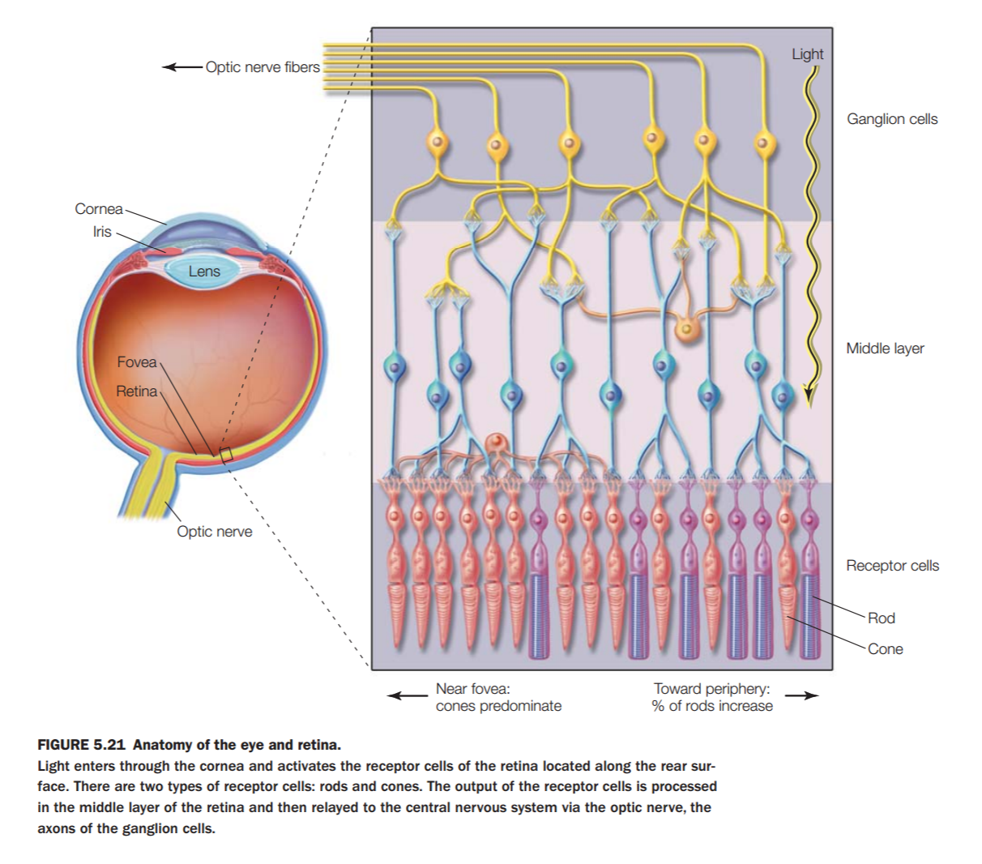

**Visual System:**

* **Eye:** The main organ of the visual system.
* **Optic Chiasm:** The main “crossover” point where the right and left visual fields cross each other on their way to the **Primary visual cortex.**
* **LGN:** Lateral geniculate nucleus, where more than 90% of the axons in the optic nerve connect to. The LGN is made up of 6 layers, with each layer playing a different role. What are those roles?
  + M-Cells: Motion detectors, rough resolution
  + P-Cells: Motor detection, fine resolution
  + Magnocellular/Parvocellular
  + Koniocellular/K-cells:
  + Heterogeneous tasks
* **Visual Cortex:** The visual cortex is the main visual processing unit of the brain.
  + **V1:** the **Primary Visual Cortex (V1)** is located in the **occipital lobe**, at the back of the brain. Because of its location, visual information has been processed by at least four distinct types of neurons before arriving: **photoreceptors, bipolar cells, ganglion cells, and LGN cells.** 
    - **Simple Cells:** A cell in the **V1** that responds primarily to oriented edges and gratings. They have distinct excitatory and inhibitory regions, follow the summation property, have mutual antagonism (they balance themselves out in diffuse lighting), and are relatively predictable in nature. Their function is simple, and are relatively straightforward to understand (see “basic bitch,” usually found waiting in line at Starbucks)
    - **Complex Cells:** These cells are similar to simple cells, except they have a degree of spatial invariance, meaning their receptive fields cannot be mapped into distinct locations/zones.
    - **End-stopped Cells:** The cells in the **V1** that allow the brain to perceive corners and curves in the environment by identifying the “ends” of a given visual stimulus.
    - **Orientation Columns:** Organized regions of neurons that are excited by visual line stimuli of varying angles. These columns are located in **V1**, and span multiple cortical layers. The orientation of these columns is perpendicular to the surface of the **V1.**
  + **Contralateral and upside-down projection**: The eyeball projects images upside down, and the brain automatically corrects it. Also, visual information on the right side is processed by the left side of the Visual Cortex, and vice versa.
  + **Receptive fields:** Neurons in the visual system have *receptive fields.* These are sensitive to the type of stimulus, and will modify the firing of the neuron based on the type of stimulus received.
    - **Center-surround:** The center-surround receptive field allows **GANGLION CELLS** to transmit information not just about whether photoreceptor cells are exposed to light, but also about the differences in firing rates of cells in the center and surrounding areas.
  + **Retinotopy:** The mapping of visual input from the retina to neurons, particularly those neurons within the visual stream. (Synonymous with “Retinal mapping”).
* **Visual Pathways:** Anterior and Posterior. Anterior: before the **LGN.** Posterior: after the **LGN.**
  + **Magnocellular:** Carry visual neural information along the upper dorsal (top) stream of the brain to help us understand motion. This magnocellular visual pathway tells us all about where things are, and how we guide our movement in relation to those objects, but not what they look like.
  + **Parvocellular:** Carry visual neural information along the ventral (bottom) part of the brain, and help us process shape, size, color, clarity, contrast, and detail.
  + **Koniocellular:** Located in the **LGN**, travelling in the ventral (bottom) part of the brain. Apparently they do lots of shit, like respond to color and gratings and sometimes nothing at all. Apparently we don’t know much about them.
  + **Eye to V1, V2:** The eye sends signals to **V1** and **V2**. (Duh)
  + **3 kinds of pathways after V1 and V2:**
    - **Dorsal:** motion, locations, “where?”
    - **Ventral:** complex shapes, object perception, “what?”
    - **Color and brightness:** color and brightness.
  + **After V2** 
    - **Dorsal (‘where’ or ‘how’):** Give you one guess
    - **Ventral (‘what’):** Okay, another guess
    - **(Color and brightness):** You guessed it! (lecture slides literally admit we don’t know much about why.)

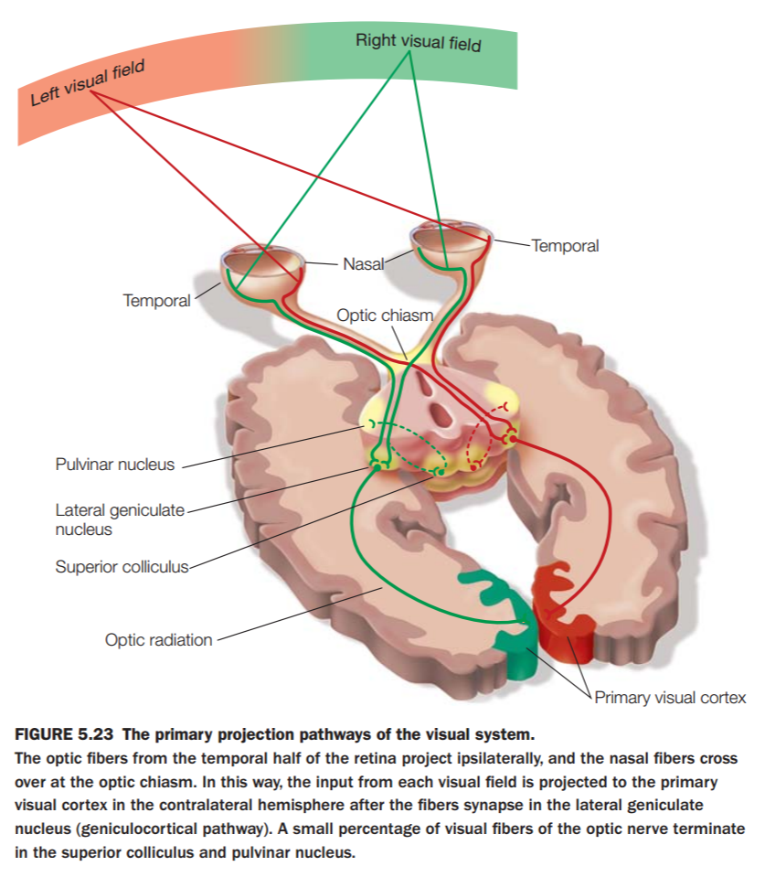

* **Perception**
  + **Perception is a unified whole (binding problem):** Our senses augment each other, and with a sense missing, the others become heightened to compensate. (Think Daredevil. Not the one with Ben Affleck, that one sucks.) The “problem” is the fact that we don’t understand completely how these perceptions combine to create a “whole” experience.
  + **Multiple pathways for visual perception:** Sometimes visual perception wants to go up (dorsal, read above) or below (ventral) depending on how it feels that day, etc.
    - **Ventral stream:** The “What” pathway of the visual system
      * **What:** “OKAYYYYYYY” – Lil’ Jon
      * **Perception for identification:** Allows us to identify shapes, sizes, colors, etc. (but not movement/location)
    - **Dorsal stream:** The “where” pathway
      * **Where:** The location pathway of the visual system.
      * **Perception for action:** Allows us to perceive location, speed, direction of travel, etc.
  + **Computational problems in perception**
    - **Object constancy:** The ability of humans to look at an object, and “imagine” what it would look like from another angle.
    - **View-invariant recognition:** Object recognition is based on structural information, such as individual parts, that allow for recognition to take place regardless of the object’s viewpoint.
    - **Shape encoding:** Once shapes are learned, they are immediately recognizable and can be “recognized” by the brain before the person can articulate that they recognize it.
    - **Grand-mother cell vs. Ensemble coding:** the hypothesis that specific neurons in the brain can automatically recognize something familiar, like Grandma, vs the hypothesis that multiple neurons encode familiarity in “ensemble.”
  + **Failures in perception**
    - **Apperceptive agnosia:** A failure in recognition that is due to a failure of perception in the visual perception pathway.
    - **Associative agnosia:** Where perception occurs, but recognition still fails.
    - **Integrative agnosia:** A combination of both Apperceptive and Associative agnosia.
    - **Category specific agnosia:** Agnosia specific to a certain type of object recognition.
* **Mind reading** (What women think they can do)
  + - **Encoding & decoding:** The ability to encode and decode perceptive patterns that allow a computer to recognize what a person is imagining based on the patterns of brain activity when that person actually sees what they’re imagining.
    - **Pattern recognition:** The ability to recognize these patterns and derive images/other media from them
    - **Application to locked-in patients:** Locked in patients can benefit from this, as they will be able to communicate with the outside world without the ability to physically interact as a normal human would.

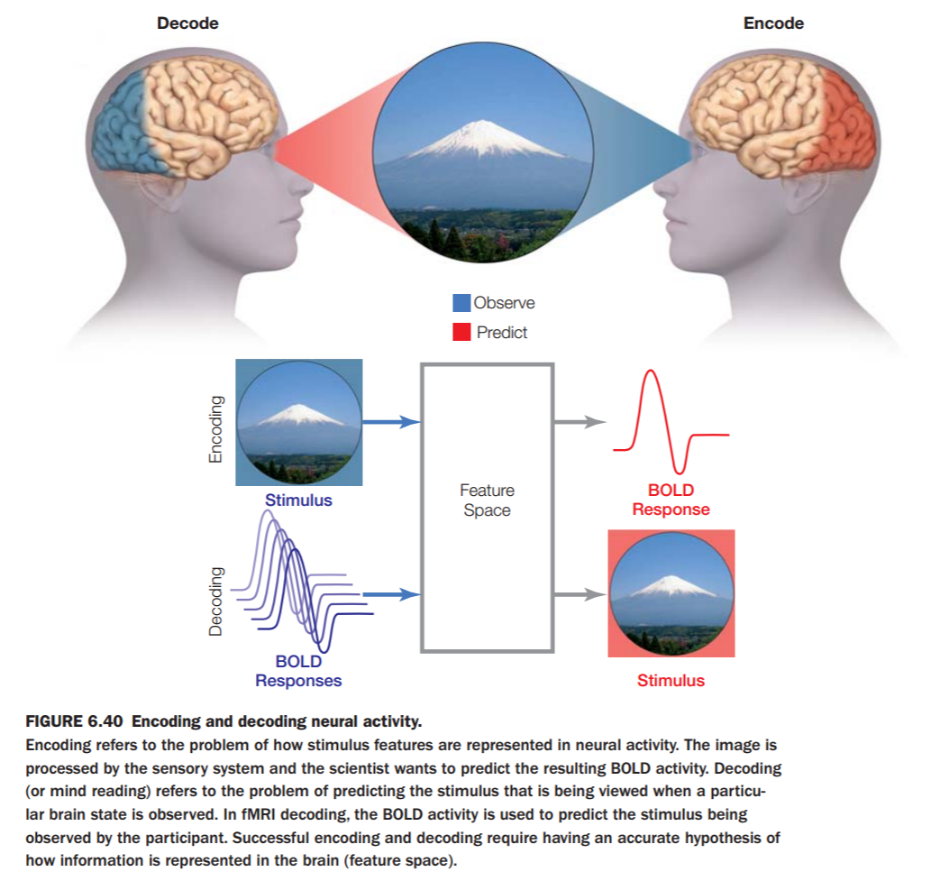

**Lecture 4: Attention**

***Reading: Chapter 7 – Attention***

**Functions of Attention**

* **Vigilance:** (Signal detection) – try to detect whether we sensed a signal to take swift action.
* **Search:** Actively looking for a signal.
* **Selective attention:** Actively focus on some information and ignoring other information.
* **Divided attention:** Perform more than one task simultaneously and shift attention between them.

**Signal detection theory**

* **Sensitivity:** High sensitivity = many hits, a few false alarms.
* **Specificity:** Many correct rejections, few misses.
* **Hit:** Where a signal pings “correctly” and the result is true.
* **Miss:** Where a signal does not ping, result is true.
* **False alarm:** Where a signal pings “incorrectly”, result is false.
* **Correct rejection:** Where a signal does not ping, result is false.

**Search:** Actively searching for an “input signal”

* **Targets and distracters:** A target is the desired “object” to be found, and distractors are unfiltered noise that makes it more difficult to focus on the target.
* **Array size effect:** The larger the “array” of objects in a field of attention, say a hundred flies buzzing around your head, the more difficult it is to focus on the target (one specific fly)
* **Feature (pop-out) search:** Proposes that certain visual features are registered early, automatically, and are coded rapidly across the visual field using pre-attentive processes.
* **Conjunction search:** Searching for a previously specified target surrounded by distractors by searching for one or more visual features.
* **Feature integration theory:** Once an object is in the field of attention, the object is either recognized or not.
  + From this “spotlight” or field of attention, we can determine certain properties:
    - Color
    - Orientation
    - Motion
    - Curvature
    - Depth
* **Similarity theory:** There must be multiple parameters to compare objects to, as we cannot determine if something is similar to another if we do not have something to compare it to.
* **Guided search theory:** There are two ways in which information is input: bottom-up (stimulus driven) and top-down (user-driven), so when the perceiver is searching for something, the level of input (an object is recognized, or a sound is very loud) has a much larger impact on whether attention will be given to that particular stimulus.
  + **Activation map:** A representation of visual space in which the intensity of the input at a specific location indicates whether the specific location contains a target.

**Selective Attention**

* **Cocktail party problem:** The moment something in your field of attention (Sight, sound, etc) that triggers a connection in your brain, the “attention spotlight” can immediately shift dramatically upon that connection being made.
  + IE: I am speaking with somebody and in the background, I hear my name spoken. My attention immediately (and involuntarily) is shifted towards the direction of my name being said, because that name triggered a connection in my brain.
* **Dichotic listening task:** A test where a user has headphones, and two separate sounds (usually speech) are input into each ear, and the user is asked to distinguish between the sounds and repeat what was said in a specific ear.
  + **Result:** The user rarely pays attention to what was mentioned in the opposite ear, and is often unable to remember what is said.
* **Posner cuing task:** An attention test that determines a user’s ability to switch tasks visually. It challenges the user to focus on one stimulus, and once a second peripheral stimulus occurs, the user must be able to determine what that second stimulus was.
* **Early filtering: Broadbent -**
  + An input reaches attentional “filter”
  + This occurs immediately after sensory input
  + Some information may pass filter
* **Late filtering:** Deutsch & Deutsch’s “Late Filtering” – this model has the filter moved later in the “signal flow”
  + This model better explains the breaking through of salient messages.
* **Treisman’s Attenuation Theory:**
  + This theory is alternative to “Late Filtering”
  + The filter modulates/attenuates analysis
  + EEG experiments support this finding
* **Voluntary attention:** Relatively self-explanatory. The perceiver chooses to focus either visually or otherwise on a given stimulus (or non-stimulus). This requires focused effort, whereas reflexive attention is automatic.
* **Reflexive attention:** A stimulus triggers attention, such as a loud sound or a flash of light. This is automatic and is particularly strong in the visual cortex, where movement and contrast have heavy weights in determining our attention.
* **Overt attention:** Deliberate focus in the visual field that dictates where a person is looking, their attention is directed in the same section of their vision.
* **Covert attention:** Discovered by **HEMHOLTZ**, he realized that the location he is paying attention to in his visual field could be different than the actual location his eyes were pointing at. This is called **covert attention.**

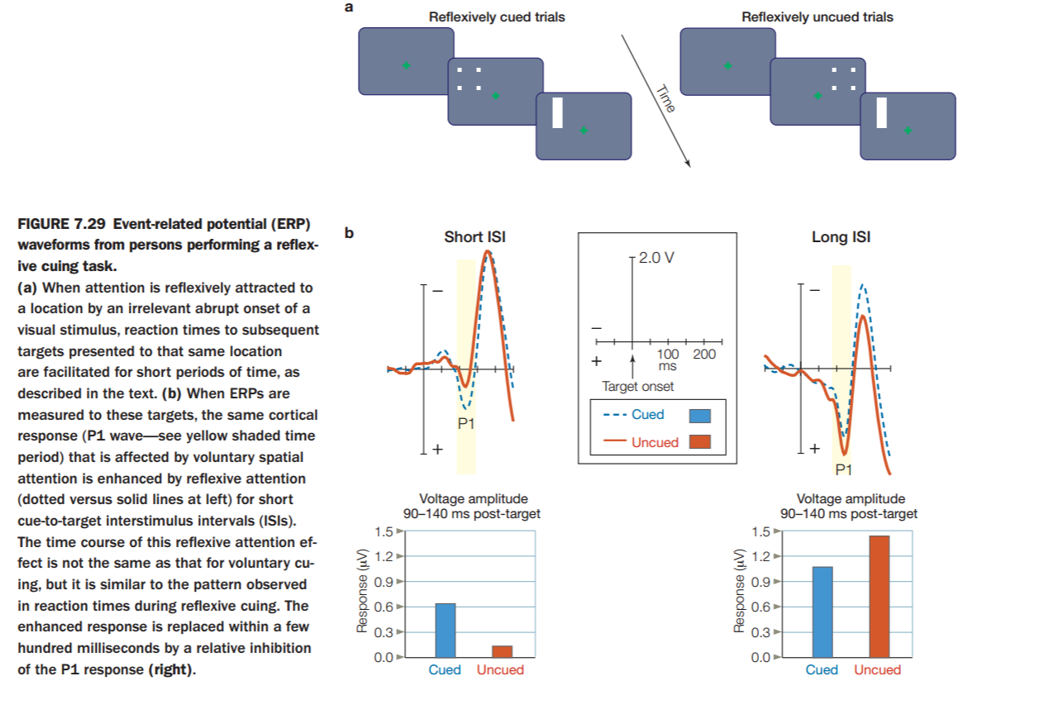

**Anatomy of attention**

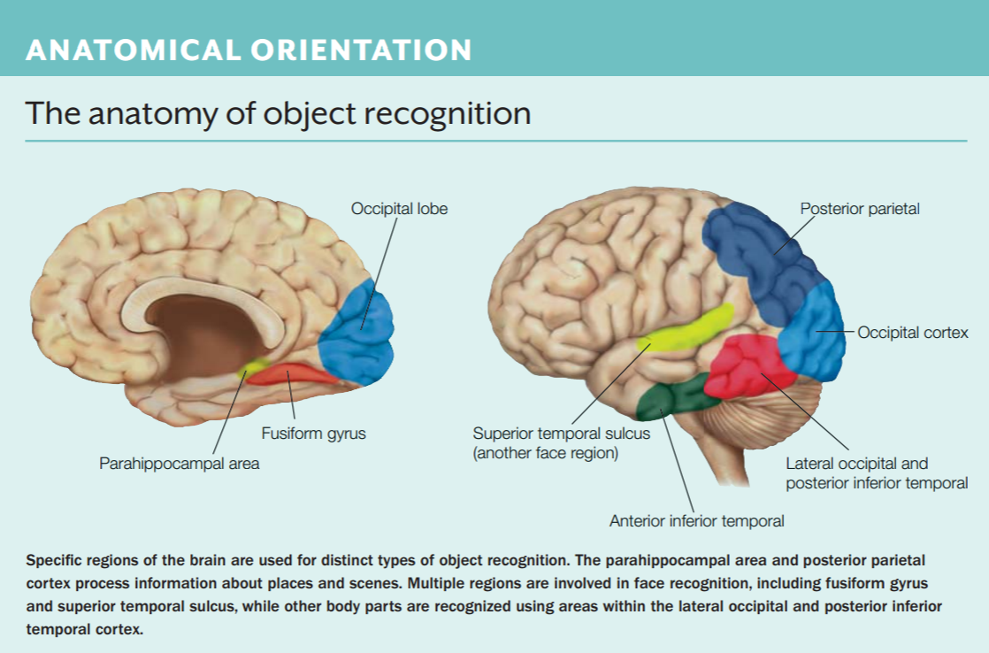

* **Cortex:** 
  + **Posterior parietal:** Information about locations and “scenes”
  + **Superior prefrontal gyrus:**  Self awareness
  + **Temporo-parietal junction:** Processes visual and auditory conscious awareness from inside and outside the body.
  + **Ventral prefrontal:** Processes risk, fear, and decision making.
* **Dorsal Frontoparietal attention network:**
  + Goal-directed control of spatial attention
  + Superior (dorsal) parietal and frontal cortex
* **Ventral Frontoparietal attention network:** 
  + Stimulus-driven control (for unattenuated salient stimuli)
  + Strongly lateralized towards the right side.
  + Inferior (ventral) parietal and frontal cortex

***(These are not the same as the dorsal and ventral VISUAL PATHWAYS)***

**Attention deficits**

* **ADHD:**
  + Inattention, hyperactivity, impulsivity.
* **Change blindness:** A deficit in our attention ability that prevents us from noticing events in our “attention periphery” if we are currently engaged/focused on a task.
* **Spatial Neglect:** Often results from damage to the parietal lobe. The inability to focus on an entire whole, (eats half the plate, no matter how many times they’re reminded there’s still something on the plate)

**Automatic and Controlled**

* **Automatization:**
  + Controlled processes can become automatic processes, such as learning to drive a car.
  + Can take a long time
  + Repeated practice reduces the rate-effect of learning – the first few practice sessions, much is learned. Over time, each session results in less learning.

**Lecture 5: Memory**

***Reading: Chapter 9 (textbook)***

**Learning and Memory: Concepts**

* ***Anatomy of memory***
* ***Memory deficits***
* ***Mechanisms of memory***
* ***Memory consolidation***

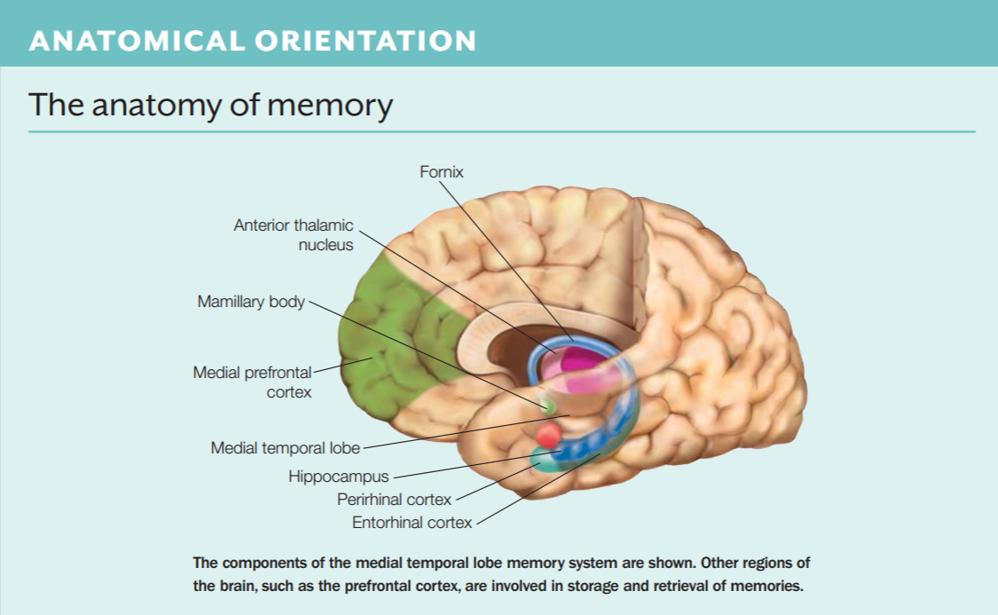

**Learning**

* **H.M. – had his hippocampus (temporal lobe) removed**
  + **Severe anterograde amnesia of declarative memory**
  + **Learn new skills, but not remember learning!**

**Memory**

* **Memory Processes:**
  + **Encoding:** processing of new information
    - **Acquisition:** sustaining some of the sensory stimuli to enter the memory system.
    - **Consolidation:** stabilize a memory over time resulting in long-term memory.
  + **Storage:** permanently record the information (into a memory trace)
  + **Retrieval:** accessing stored information to use it.

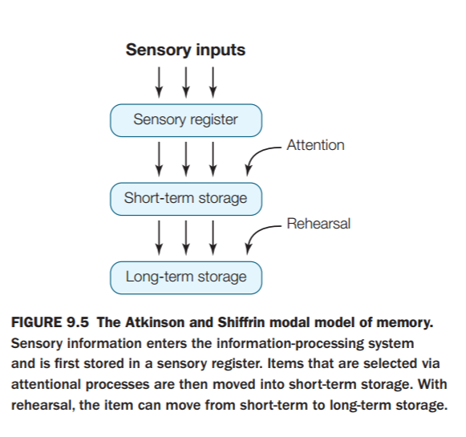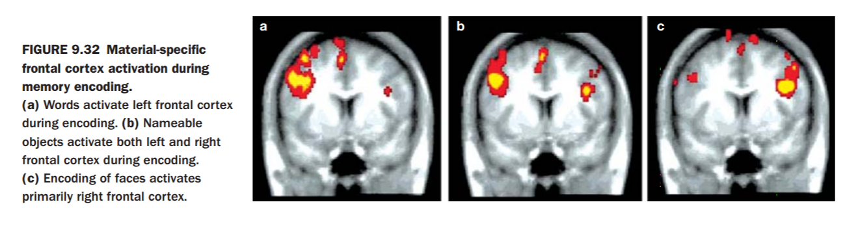 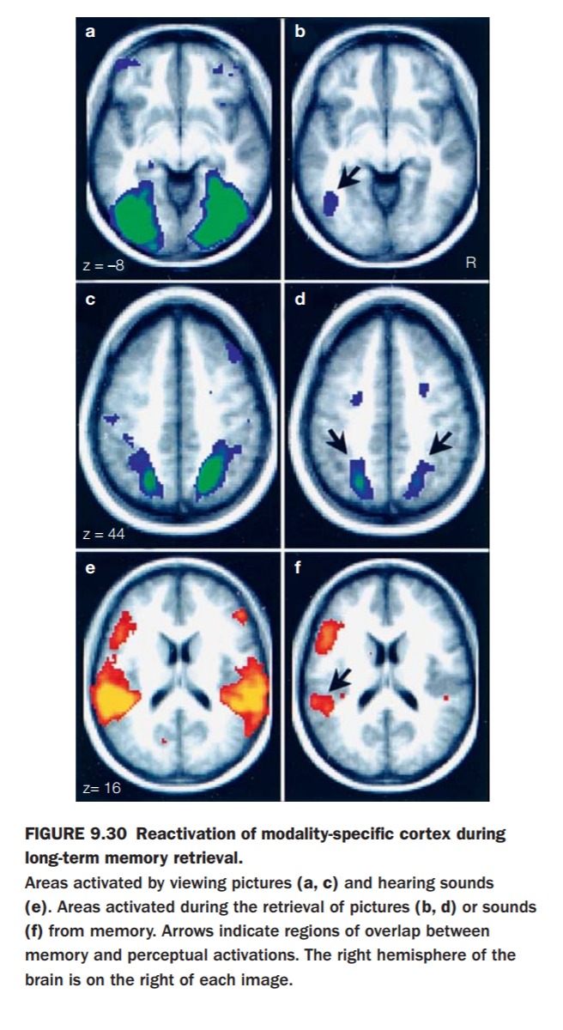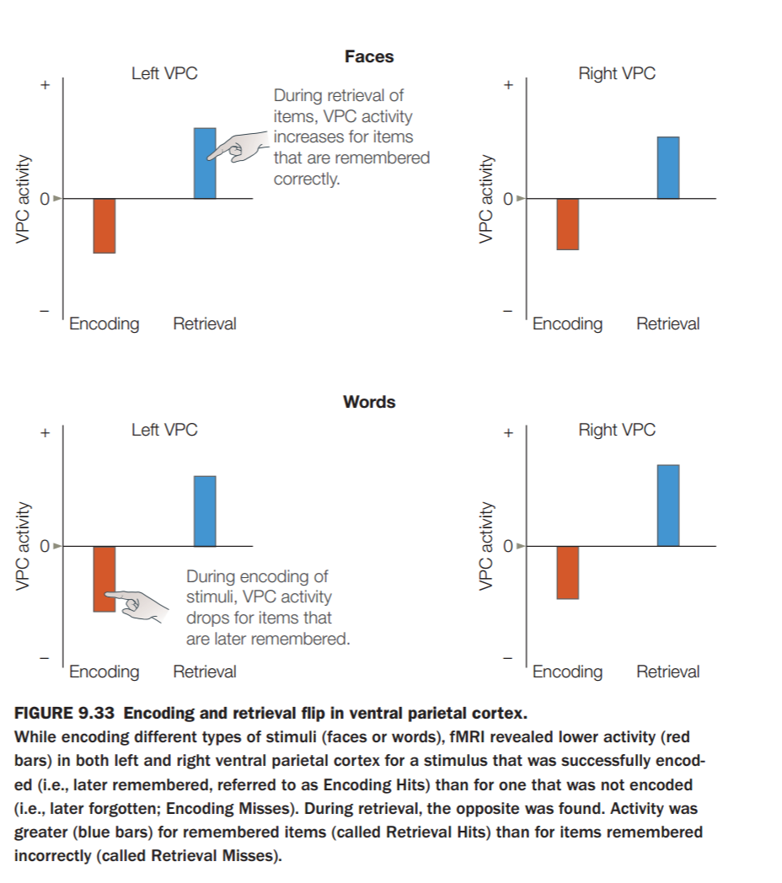

* **Types of Memory:**
  + **Short Term**
    - **Sensory:**
      * Visual: *Iconic store*
      * Auditory: *Echoic store*
      * Information decays rapidly (~0.5 seconds)
      * Information is fragile, can be easily erased/replaced by other stimuli
    - **Short-term:** 
      * Limited capacity, usually (7 items, +/- 2 items, according to ***Miller***).
      * Holds memory longer than sensory stores (~30 seconds). T
      * his memory is fragile, can be easily disrupted.
  + **Long Term:** Virtually an unlimited space for storage, can hold information “permanently”
    - **Declarative:** (explicit memory)
    - **Non-declarative:** (implicit memory)
      * Procedural memory, such as skills and motor/cognitive
        + Memory of tasks or procedures

Riding a bike

Driving a car

* + - * + AKA – memory for automatic processes
      * Conditioned responses between two stimuli
* **Memory Models:**
  + **Atkinson and Shiffrin:**
    - The modal (or multi-store) model
      * Sensory inputs -> sensory register -> short term storage (attention) -> long-term storage (rehearsal)
  + **Baddely: Working Memory Model**
    - Replace the STM with a working memory component
    - Key differences than the STM
      * Emphasis on working memory, with maintenance and manipulation
    - WM accesses both STM and LTM interactively
    - WM represents activated part of LTM
    - Neural correlations
    - Transfer from STM to LTM
      * **sConsolidation**: integrates new information
      * Techniques:
        + Rehearsal: elaborative or maintenance
        + Distributed is more effective than massed
        + Mnemonics: add meaning to lists
* **Memory Processes:**
  + Free recall experiments show serial position curve
    - **Primacy effect:** superior recall of item near beginning
    - **Recency effect:** superior recall of item near end
  + **Constructive Memory:**
    - Memory is not only ***re***constructive, it is also ***con***structive
    - Prior experience has an influence on memory
    - This is a problem with eyewitnesses, as the way a question is asked influences the answer given
    - Context plays an important role
  + **Flashbulb memories:**
    - Where were you on 9/11?
      * You tend you remember many intimate details when you learn shocking news.
  + **Memory Encoding Specificity:** memory performance is optimal when there is a match in processes and context between learning and retrieving.
* **Anatomy of Memory:**
  + **Hippocampus** is essential for memory **consolidation.**
  + Standard consolidation theory (Squire):
    - Memory consolidated fast in hippocampus via Entorhinal cortex
    - During sleep is consolidated into other parts of cortex
  + **Place Cells:** located in the hippocampus
  + **Grid Cells:** entorhinal cortex
  + **Place and Grid Cells are the brain’s “GPS”**
    - Grid cells have connecting centers that form a triangular grid. These cells allow the brain to determine its location in space.

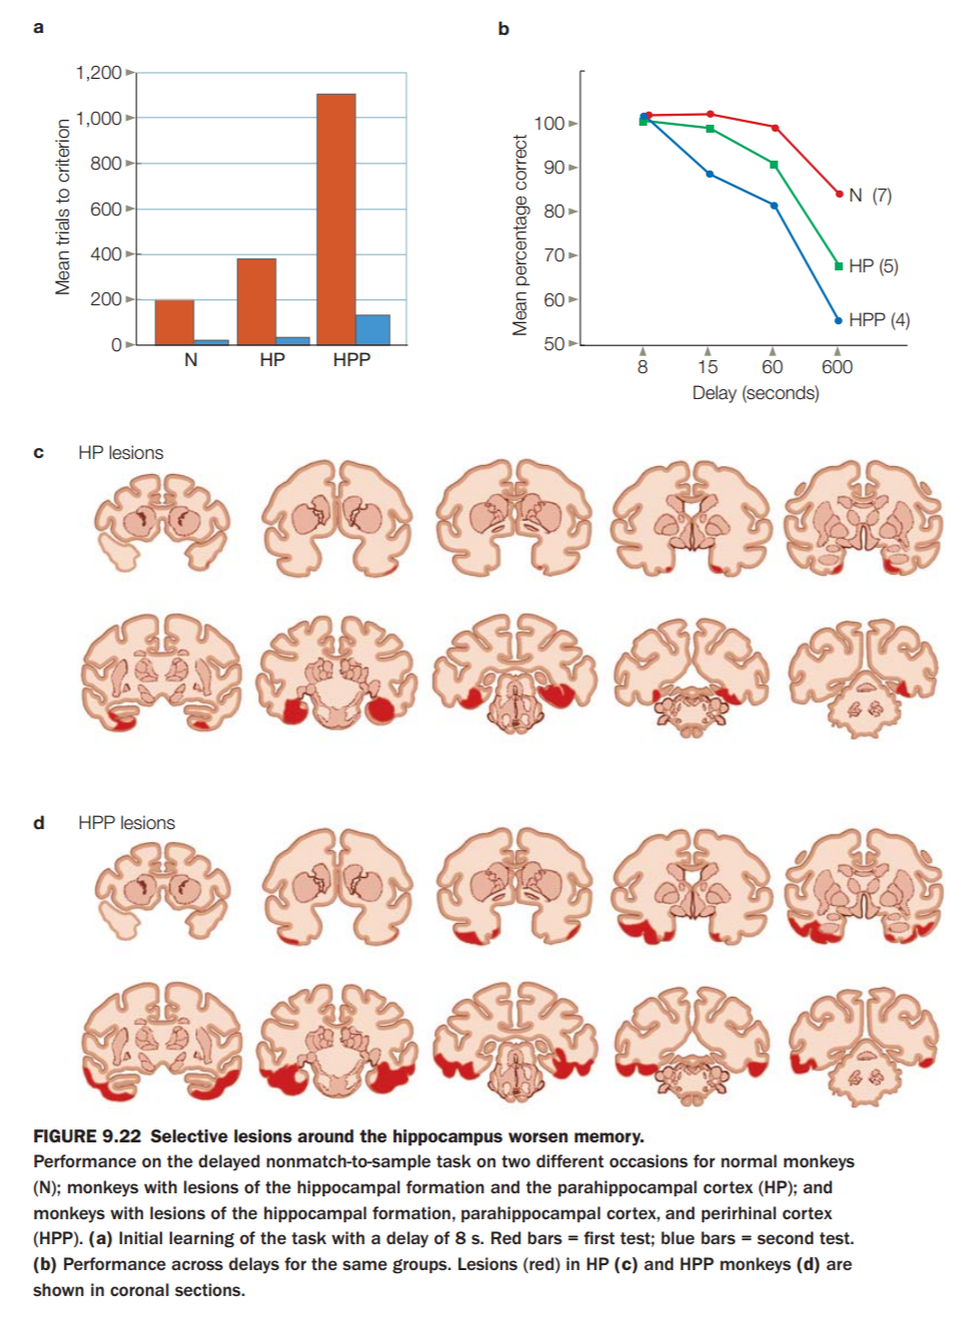

* **Memory deficits:**
  + **Amnesia**
    - **Retrograde:** for events before the injury. Loss of memory for events that happened in the past.
      * No retrieval
      * **Ribot’s law:** more likely of loss of most recent events (closest to the injury) in retrograde amnesia, than past events
      * Usually temporary (after accident)
    - **Anterograde:** for events after the injury. Loss of ability to form new memories.
      * No memory consolidation
  + **Alzheimer’s:**
    - Amyloid plaques and neurofibrillary tangles in the brain
    - Memory impairment, and later general impairment
    - Starts with episodic memory, in the entorhinal cortex
    - Largest risk factor: age 6% (>80 years)

**Lecture 6: Learning**

***Reading:***

* ***Chapter 9***
* ***Ballard: Introduction to Natural Computation (PDF)***
  + ***Chapter 1.1, 1.2, 1.4.2, 1.5***
  + ***Intermezzo***
    - ***The cortex as hierarchical memory***
    - ***Neural network models***
  + ***Chapter 8 – supervised learning***
    - ***8.2 - perceptrons***

**Learning:** process of acquiring new information.

**Memory:** Storage of retrievable information, outcome of learning.

* **Hebbian Learning:**
  + **Associative learning**
    - Cells that fire together, wire together
    - Cells that fire together, strengthen synapses
    - Cells that fire separately, loosen synapses
* **Long-term potentiation (LTP)/depression(LTD):**
  + A molecular mechanism for (Hebbian) learning
  + **LTP**
    - (E)PSP is **increased** after presynaptic stimulation
    - Long-term synapse **strengthening**
    - Takes place at all 3 main synaptic sites in the **hippocampus**:
      * Perforant pathway synapses in the dentate gyrus
      * Mossy fiber pathway synapses in CA3
      * Schaffer collateral pathway synapses in CA1
    - **Associative LTP:**
      * Implementation and extension of Hebb’s law
      * Properties:
        + **Cooperativity:** works when more than 1 input is simultaneously active
        + **Associativity:** Weak inputs are potentiated when concurring with stronger inputs
        + **Specificity:** only the stimulated synapse shows potentiation
  + **LTD**
    - (E)PSP is **decreased** after presynaptic stimulation
    - Long-term synapse **weakening**
  + ***Shown at multiple stages in the hippocampus***
    - (also in Cortex, Cerebellum, Subcortical Nuclei)
  + **NMDA Receptor:**
    - Central to producing LTP, but **not** to maintain it
    - **When the NMDA receptor opens:** 
      * **Glutamate** binds
      * **Post-synaptic cell is depolarized**
      * **Mg2+** ejected out of channel
      * **Ca2+**enters and facilitates **LTP**.

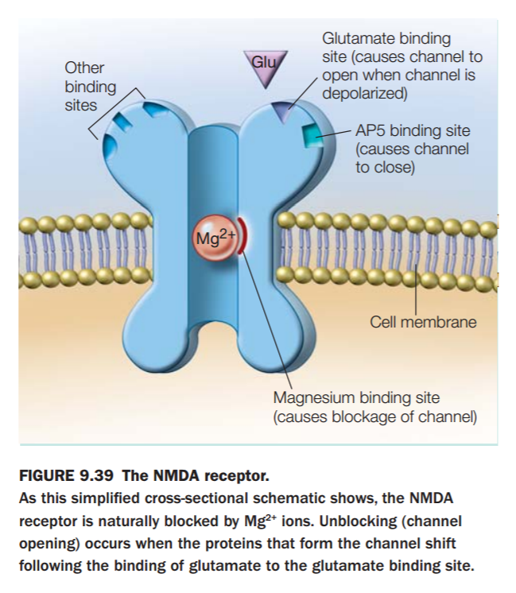 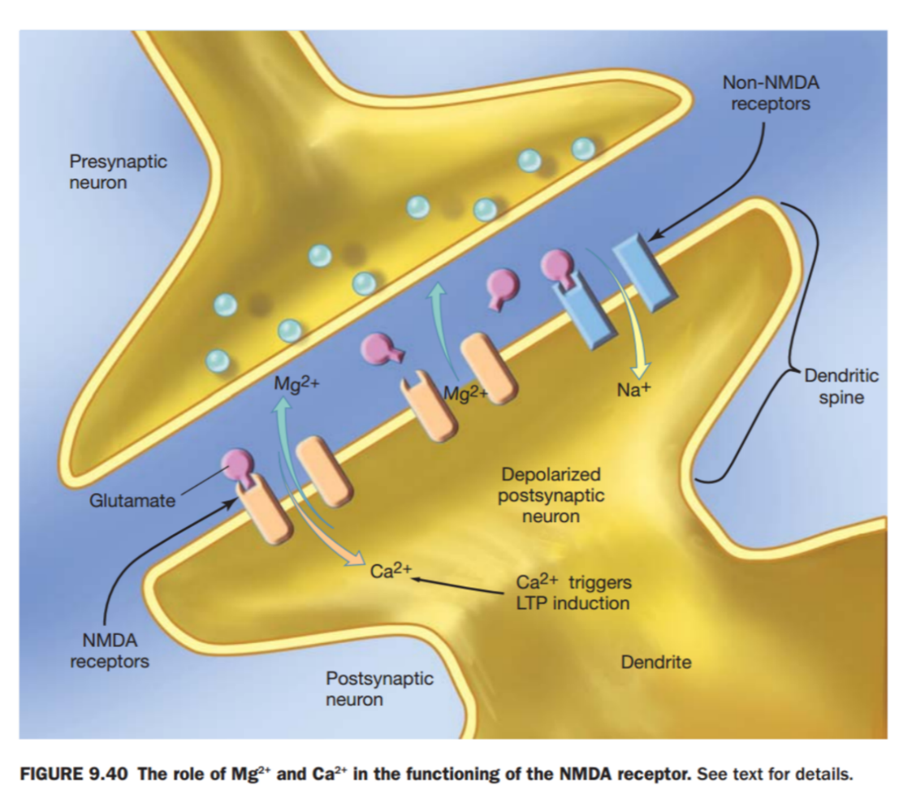

**Artificial Neural Networks:**

* **Types of learning:**
  + **Supervised:** (teacher) (categorization is important)
    - There is a correct output associated with the given output
  + **Unsupervised:** (all on your own) (error is important)
    - There is no correct answer associated with the given output
  + **Reinforcement:** (rewards)
    - There is a good/bad reward given when the right/wrong answer is given.
* ***What are they?***
  + A **very crude** approximation of a biological neural network
  + Consist of **nodes** (artificial neurons, units)
    - A node has an **input/output**
    - Performs simple computation (activation function)
  + Connections between nodes
    - Each connection has a **weight** (synaptic strength)
* **Types of general structure:**
  + **Fully connected**
    - All units connected to each other
  + **Feed-forward ->**
    - One **layer** to the next
  + **Recurrent network**
    - Contains some “back connections”
* **Input Function:**
  + ini = ∑j W(j,i) ∙ ak = Wi∙ai
  + This weighted sum is transformed into an activation value called an **ACTIVATION FUNCTION.**
* **Activation Function:**
  + Step function
  + Sign function
  + Sigmoid function
  + The threshold is usually not hardcoded
  + Uses a bias-node
  + The bias-node (a0) has constant output of 1 or -1
  + Threshold t is determined by the weight W0,j
  + Mathematically: bias-node = -threshold
* **Perceptron:**
  + Has an input layer and an output layer
  + Uses the step or sign function
  + Single-layer, feed-forward network
  + Because of the step or sign function: binary activation
  + **Learning in the perceptron:** 
    - Algorithm in words:
    - Calculate the error (What values can this error take, assuming a step function?)
    - If error = 0 Then Stop
    - Else adjust the weights
    - Adjusts weights only if input != 0
    - Increase weight if error = 1, decrease if error = - 1
  + **Perceptron Algorithm:**
    - If error (=target output – current output) != 0 Then
    - Weight change = (some small constant) x (error) x (input)
    - In one go:
      * Weight change = (some small constant) x (target output – current output) x (input)

**Lecture 7: Research Methodology**

***Reading: Chapter 3 (KRCP Textbook – Methods of Cognitive Neuroscience)***

(fMRI techniques are important to understand)

***Concept Checklist – Lecture 7 + Literature:***

***Chapter 3: methods of cognitive neuroscience***

* ***Methods to perturb neural function*** 
  + ***Structural analysis of the brain***
  + ***Methods for the study of neural function***
  + ***The marriage of Function and Structure: Neuroimaging***
  + ***Converging methods***

**Concepts**

* **Research design**
  + **Correlational:**
    - Measure variables only as they occur.
    - Used to determine if there is an **association(!).**
    - You can ***NEVER*** infer causal relationships.
  + **Experimental:**
    - Involve manipulation of one variable.
    - Keep other variables constant.
    - **CAN** show a causal relationship.
* **Computer modeling:** Simulates models of cognition inside the computer. We use them to generate **Testable Predictions.** Most well-known models are based on “connectionistic” models, such as **neural networks.** 
  + **Symbolic modeling:** Serial and abstract processing, such as Expert Systems.
  + **Connectionism:** Parallel and distributed processing, such as Artificial Neural Networks.
  + **Realistic neuronal modeling:** IBM BLUE Brain, EU Human Brain Project, et.
  + **Breitenberg vehicles:** An agent that can autonomously move around its environment based on the input from a few basic sensors. It has primitive sensors that measure stimulus, and wheels that function as actuators. Depending on the sensory input, it can appear that this object is acting intelligently, when in fact it might be a much simpler explanation.
  + **Pros:** Much closer to Marr’s implementational level, which eventually will lead to neuromorphic computing (where a computer can change its own network).
  + **Cons:** Can oversimplify problems, not always biologically plausible, some models are too complex to generate desired behavior, oftentimes many models to achieve similar solutions.
* **Lesion Studies:** The study of damage to the human brain allows us to understand functions of certain parts. (If something is damaged, the changes in behavior are often linked to the damaged region)
  + **Dissociations**
    - **No dissociation:** One lesion impairs A and B
    - **Single dissociation:** One lesion impairs A and B, other only B
    - **Double dissociation:**  One lesion impairs A, other B
  + **Pros:** Gives insight to damage.
  + **Cons:** Brain is complex, damage to one part could affect another, skewing results. Results in a non-healthy brain! Not a dependable source of research.

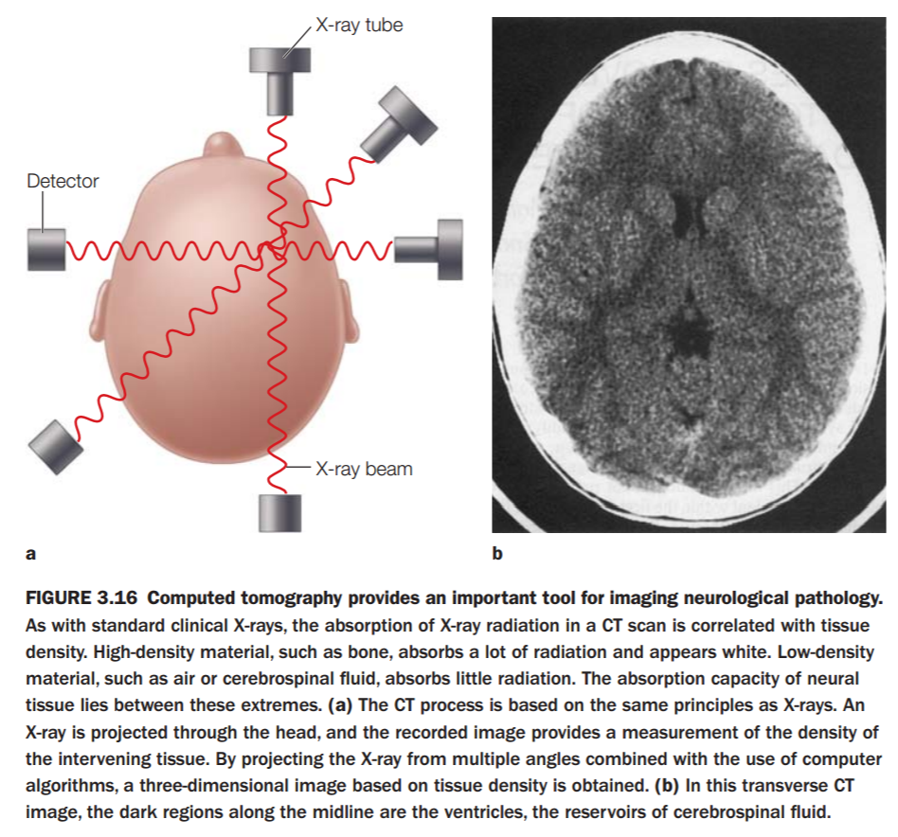

* **Structural Imaging**
  + **CT / CAT:** Computed Tomography. Uses X-Rays. Different tissues absorb different amounts of X-Rays, shows contrast between tissue. Is radioactive, causes damage, not always feasible for prolonged study.
  + **Structural MRI:** Magnetic Resonance Imaging.
    - **MRI system:** Causes spinning atoms in the field to align to magnetic North/South. Then, a radio wave is beamed into the field, causing unmatched atoms to align in opposite directions. When the radio wave is turned off, atoms realign, releasing energy. We can measure this energy.
      * **Magnet (1.5T – 9.4T):** higher number = higher magnetic field
        + **Why higher fields?** The higher the Tesla rating, the higher the magnetic field, which results in more accurate readings.
      * **Gradient coils:** Creates a **secondary** magnetic field (in a predictable manner) that allows us to alter the resonant frequency of certain atoms.
      * **Radio frequency coil:** Beams radio waves into the field.
    - **Protons / spins:** Spinning atoms, what we measure in an MRI
    - **Larmour frequency:** The frequency of the radio pulse, determined by the gyromagnetic ratio: Hz/Tesla
    - **Gyromagnetic ratio:** Hertz/Tesla
    - **T1 weighted, T2 weighted, T2* weighted:** Different relaxation times (of the spins realigning) give different contrasts, enhancing images.
    - **Diffusion MRI / DTI:** Uses the diffusion of water molecules to enhance contrast in MR Images.
      * **Anistropic diffusion:** Directional diffusion within the brain. Useful for determining structures in the brain that restrict the flow of water, such as myelinated axons of nerve cells. (Affected by Multiple Sclerosis)
    - **Pros:** Gives us increased clarity in the flow of water throughout the brain
    - **Cons:** Doesn’t tell us much about injuries/lesions.
* **Functional Imaging:**
  + **Single cell recording:** Famous experiment by Hubel and Wiesel. Cells in the **V1** (see visual cortex) respond in a specific manner.
    - **Pros:** Gives very high resolution.
    - **Cons:** Highly invasive, does not give the whole picture.
  + **EEG:** Electroencephalogram measures overall brain activity **OVER TIME.** High temporal resolution. Uses electrodes to measure activity of groups of neurons that fire in parallel.
    - **ERP:** Event-related potential. Once an event occurs, we can measure the brain activity as it happens.
    - **Time-frequency analysis:** We don’t always see everything. Do the same thing over and over again, and average the results.
    - **ECoG:** Electrodes are placed directly on the surface of the brain. Much more invasive, but less noisy.
    - **Pros:** Very cheap, very high temporal resolution.
    - **Cons:** Very poor spatial resolution, very noisy, impossible to detect sources of signals.
  + **MEG:** Magnetoencephalogram. Measures same activity as EEG, but is less mobile yet more accurate in location.
    - **Pros:** More accurate in spatial resolution, contrast.
    - **Cons:** Less mobile, practical.
  + **PET:** Positron Emission Topography. Measures brain activity through a tracer (substance given to patient, sits in bloodstream)
    - **Annihilation & gamma rays:** (?)
    - **Subtraction method:** Allows us to determine very specific locations in the brain using subtraction of a control vs affected image.
    - **Pros:** You can measure what you trace depending on the substance given.
    - **Cons:** Radioactive substance must be imbibed, has been replaced by better methods. Experiments are short (radioactive decay). Very expensive.
  + **fMRI:** Functional MRI. Goes beyond Subtraction Method. Relies on the General Linear Model.
    - **BOLD, oxyHb and deoxyHb**: Oxygenated vs Deoxygenated Hemoglobin (Hb) has different resonant magnetic frequencies.
    - **BOLD =** Blood Oxygen Level Dependent responses. Gives us an insight to mixture of blood flow/volume in brain.
    - **Block design & event-related design:** Create an event and measure the response over time (2-3 seconds)
    - **Rt-fMRI, BCI & Neurofeedback:** Real-Time fMRI, record results as they happen. BCI = Brain Computer Interface, allows us to control computers via thought. Neurofeedback feeds brain activity back to the subject. Subject can “train” their thoughts to control devices via BCI.
    - **Pros:** Very high spatial resolution. Relatively high temporal resolution. Non-invasive.
    - **Cons:** Temporally limited, but not that badly.
  + **Spatial & temporal resolution:** Spatial = location, Temporal = time.
    - **Relative resolutions of modalities:** 
      * **Log size vs. log time plot**
* **Methods to perturb function:** Perturbing function is altering the function of the brain, whether through drugs, stimulants, or otherwise. Because damage to the brain does not necessarily tell you what the function of the damaged portion does (Removing the spark plug from an engine does the same thing as running out of fuel, but they’re two different things entirely), focusing on more localized, controlled “perturbation”
  + **Pharmacological studies:** There are certain studies that introduce certain types of chemicals, or drugs, known as **agonists** (which act like neurotransmitters and mimic/increase neurotransmission) and **antagonists** (which bind to cell receptors and block or somewhat dampen neurotransmission). These studies allow us to study the direct effects of certain neurotransmitters or other chemicals on cognitive function.

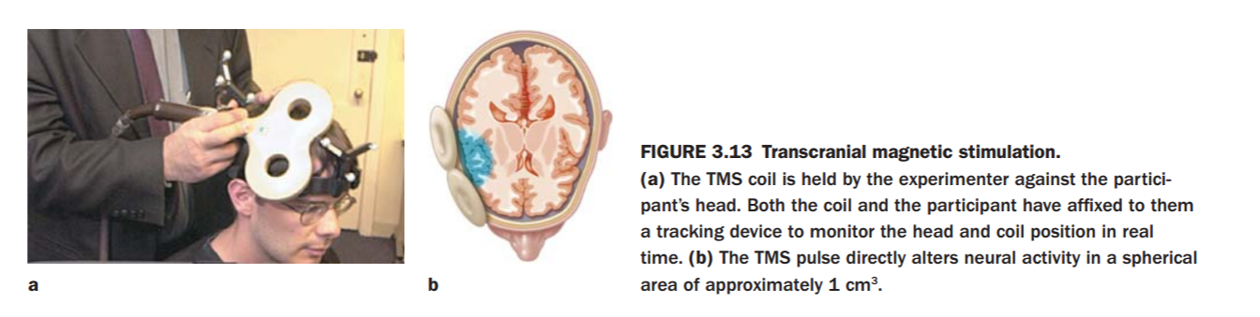

* + **TMS:** Transcranial Magnetic Stimulation – a large coil generating a strong magnetic field is placed on the skull and causes certain neurons to fire. The mechanism is poorly understood, though the applications are many.
    - **Pulsed TMS:** Pulsing the magnetic field, we are able to time any given stimulus with the TMS pulse to prevent certain actions from happening, such as pulsing in the **visual cortex** between 70-130ms after the subject is shown a certain letter in the alphabet, preventing them from identifying and naming the letter.
    - **Repetitive TMS:** Performing TMS to specific regions of the brain repeatedly over many sessions can allow certain patients with physiological or psychological disorders to experience temporary relief. The more often and prolonged a session is, the longer the residual benefit.
  + **tDCS:** Transcranial Direct Current Stimulation – An anode and cathode are placed onto the scalp, where neurons underneath these terminals become depolarized, allowing them to become much more excitable and therefore more likely to trigger an AP when a specific stimulus occurs.
  + **Genetic manipulation:** One of the greatest scientific challenges of today is in the manipulation of genes to determine the eventual outcome of human development. The Human Genome Project was able to successfully map the entire human genome, and now the challenge lies within decoding all of the information, and determine which genes lead to which type of development, such as which genes lead to the development of brain tissue vs muscle tissue, etc.
    - **Knockout procedures:** A type of experiment on animals where scientists “knock out” a specific gene, and let the specimen develop otherwise normally to see if they can’t detect what changes their manipulation leads to. For example, certain types of mice with “knocked-out genes” were unable to develop their cerebellum fully, leading them to develop poor motor control.

**Lecture 8: Evolution and Development**

***Reading: Chapter 2 – Development of Nervous System***

***Ballard: Chapter 12, Intermezzo***

**Topics:**

* **Evolution of the brain**
  + ***Development and plasticity***
* **Genetic Algorithms**
* **Applications**

**Evolution of the Brain:**

* Homo Sapiens has the largest brain size to body size ratio
  + Porpoise and dolphin are very close
* In a simple life form: genes determine every position and function of a nerve cell
  + Is this the same for more complex life forms?
* A single byte (8 bits) can represent **4 DNA** base pairs. In order to represent the entire diploid human genome in terms of bytes, we can do the math and realize that:
  + 6x109 base pairs/diploid genome x 1 byte/4 base pairs = 1.5x109 bytes, or **1.5 Gigabytes** of data.

**Radial Unit Hypothesis:**

* How did the human brain expansion happen?
* This can be explained by the “**Radial Unit Hypothesis”**
* What is this hypothesis?
  + First cells divide symmetrically: keep the same function
  + After this, they divide asymmetrically: one cell has a different function than the other (IE -> Neuron)
  + The cortex is formed from an inside-out manner
  + New neurons migrate radially into the newly forming cortex
  + By prolonging the first stage, you get exponentially more neurons
  + **Phases:**
    - Proliferation
    - Migration
    - Specialization
    - Synaptic pruning & neural death
  + This does not mean the number of neurons alone is the whole story with bigger brains!
  + More cortex does **NOT** just mean more neurons
  + Moreover, only 19% of the 80-100 billion neurons in the human brain are in the cortex
    - Similar percentage to other mammals
    - 80% is in the cerebellum
* Myelination of axons extends further into life than other developmental processes
* Axons in different cortical areas myelinate at different times
  + Sensory and motor areas first
  + Frontal and parietal areas last
* Myelination of frontal cortex continues way into adulthood
  + Some estimates say up until age 25-30
* So you don’t just “use it or lose it” …
  + ***But use it now (in your 20s) or never get it!***

**Genetic Algorithms**

* **The concept of evolutionary changes can be represented by algorithms**
* **Genetic strings** (0010110101 – for example)
  + This represents strands of our DNA
  + A genetic algorithm has a large number of strings/genotypes
  + Each genotype is called “an individual”
  + A collection of individuals is called a “population”
  + Each string/genotype/individual is assigned a **fitness value** according to phenotype
  + This fitness value can be normalized to a range between 0 and 1
  + You can use anything you like to calculate your fitness value
* **So how does this population reproduce?**
  + First a GA selects individuals who may reproduce
  + Reproduction is achieved by two operators:
    - Cross-over: combine two individuals
    - Mutation: randomly alter a bit (usually a low rate of mutation)
* **Selection:**
  + **Elitist selection:**
    - Order individuals by fitness
    - Select top 10, 20, etc.
    - Advantages:
      * Very straightforward to implement
    - Disadvantages
      * Each generation loses a lot of genetic information
      * “genetic degeneration”
  + **Roulette Wheel selection:**
    - Much more random
    - **Advantages:**
      * Better than elitist selection
    - Disadvantages:
      * Comes very close to elitist selection if fitness values are very unequal
  + **Tournament selection:** Selecting the very best individual(s) out of any “tournament” or comparison, and allowing **only that individual(s)** to reproduce.
  + **Pros and Cons of selection**
  + **theories:**
    - One must be aware of what sort of result they are looking for. Elitist selection will result in very limited gene pools, where are Roulette Wheel selections will result in more random results, that are more heavily dependent on the fitness values.
* **Genetic Algorithms - Pros and Cons:**
  + Genetic algorithms are very basic, of course the human genome is extremely complex and without a thorough understanding of an organism’s genes, it is very difficult to accurately mimic the biological genetic development process.

**Lecture 9: Language**

***Reading: Chapter 11 – language***

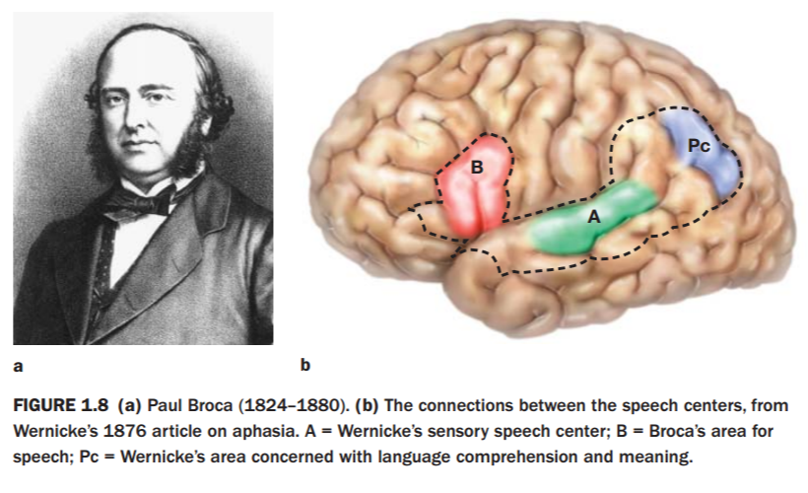

**Origins:**

* **Mirror Neurons**:
  + Neurons that fire **both** when the subject performs and action, and when it observes **the same action performed by a different subject.** (Moving your hand, and somebody else moving their hand)
  + Motor cells that produce motion and respond to sensory information about motion
* **Missing Link?** (Rizzolatti & Arbib) – The idea that due to **Mirror Neurons**, humans are capable of developing language because we are able to mimic what we observe. When somebody says something, that triggers a response in our language center, and when we are old enough to reproduce that sound, it fires again, creating a link between imitation and pure creation.
* **Primate brain area F5**
  + Codes for hand and mouth movements, contains mirror neurons.
* **Human homologue:**
  + **Broca’s area** – speech production, also contain mirror neurons

**Language Acquisition:**

* **Stages: The rate of language acquisition is uniform across all demographics and locations**
  + Cooing (birth)
  + Babbling (6 months)
  + One-word utterances (1 year)
  + Multiple words (1-3 years)
  + Basic adult structure (3+ years)
* **Errors:**
  + Children make lots of errors when learning language:
    - **Overextension errors:** The “overextension” of a word’s meaning to apply to other things, such as a small child calling all 4-legged animals “doggie,” or all men “daddy.”
    - **Irregular Verb errors:** Best described with an example: “I have a computer” is correct, while “I has a computer” is incorrect.
    - **Critical period:**
      * There seems to be a critical period for language acquisition
      * As you get older, you may learn a language, but never with the same mastery as you could when you were younger.
* **Multilingual:**
  + Bilingually raised children might have a slight disadvantage in their primary language compared to monolingual children, though this disappears as they get older.
  + **Many advantages regarding executive functions**
    - Task switching
    - Inhibition (overcoming strong habits, resisting temptation)
    - Planning and decision making
    - Error correction / troubleshooting
* The field of **Linguistics** is the study of language
  + For something that comes naturally to us, language is remarkably complex
  + **Language**:
    - Production
      * Speech
      * Writing
    - Comprehension
      * Spoken
      * Written
      * Signing
  + Language consists of several components:
    - **Syntax**: rules that tell us how to organize words (grammar)
      * Phoneme: smallest unit of speech
      * /t/, /s/, /b/
      * Grapheme: smallest unit of written language
    - **Semantics**: meaning of language
      * **Morpheme**: smallest unit with meaning
    - **Lexicon:** mental store of word information
    - **Prosody:** Rhythm and pitch of speech
    - **Pragmatics:** Knowledge of social rules
* **Lexicon (cont.):**
  + A networked web of words and **semantics**, and how they’re related. (IE: Heat and Fire)
* **Language is left-lateralized (centered in the left half of the brain)**
  + Broca’s area
  + Inferior temporal cortex
  + Superior temporal gyrus
* **Language Deficits:**
  + **Aphasia:** A broad term meaning some form of deficit in language comprehension and/or production.
  + **Broca’s Aphasia:** The most studied form of Aphasia. ***Hodor from Game of Thrones has Broca’s Aphasia***, because he can only utter one word. This was discovered when Broca, a French physician from the 19th century, discovered via autopsy a damaged left inferior frontal gyrus in a man who could only say one word in his lifetime, “tan.” This area is now called **Broca’s area.**
  + **Wernicke’s Aphasia:** A difficulty in understanding spoken and/or written language. Often accompanied by total inability to understand language at all. Although what they say is fluent with normal rhythm and grammar, what they will say is totally nonsensical.

**Lecture 10: Reasoning and Intelligence**

***Reading: Chapters 11+12 (STERNBERG BOOK, NOT KRCP TEXT)***

* **Deductive Reasoning:** Conclusions follow *certainly* from the premises.
  + **Premises:** A statement concerning only facts (do not have to be true, but rather empirical) – “Some students pass this course.”
  + **Quantifier:** “A word/statement concerning the premise that give it specific context. “Some students pass this course.”
  + **Conclusion:** “Some students study for this course.”
  + **Atmosphere effect:** The “atmosphere” of a statement, or the context in which is it given, can influence the user’s ability to reason. “All students drink alcohol, therefore all students are alcoholics.”
  + **Categorical reasoning:** Consists of a premise followed by a quantifier.
  + **Conditional reasoning:** Contains a premise and conclusion.
    - **Syllogistic reasoning:** The most common form of deductive reasoning is ***Categorical Syllogistic Reasoning***. A syllogism consists of **premises** followed by a **conclusion.**
      * **Modus Ponens (Method of affirming):** If P2 = p, then the conclusion = p
      * **Modus Tollens (Method of denying):** if P2 = !p, then the conclusion = !p
      * **“Denying the antecedent” error:** *P=>Q : if not P, then not Q.* This is incorrect.
      * **“Affirming the consequent” error:** *P=>Q : Q is true, therefore P is* true. This is also incorrect.
    - **Wason selection task:** A common logical task.
      * Four cards are on the table, with a letter on one side and a number on the other. Tell the participants an arbitrary rule, and ask them which card they must flip over to test if the rule is correct.
      * This is a difficult task when implemented in a formal manner, but when it becomes practical, the success rate skyrockets to about 75%.
* **Inductive Reasoning:** from a large body of evidence, we make conclusions that are *probably* true. Based on observation, yet the hypothesis ***cannot*** be officially proven (must use statistics to prove the probability of being true).
  + **Heuristics & Bias:** Heuristics are “rules of thumb”
    - **Availability heuristic:** We are biased by our experience with the availability of experiences, by recentness and frequency.
    - **Representativeness heuristic:** We are biased by the way information is presented to us, even if the information is obviously correct/incorrect, the manner in which it is presented is critical in our reasoning techniques.
* **Expertise:**
  + **Three stages of skill acquisition**
    - **Cognitive stage:** The processes of developing declarative encoding
    - **Associative stage:** errors eliminated and good actions strengthened
    - **Autonomous stage:** no more “thinking” required, automatic actions
  + **Power law of learning:** T=aP-b.
    - **T =** Time needed to solve a task
    - **A =** Learning constant
    - **P =** Practice
    - **b =** learning constant.
  + **Tactical learning:** Learning the sequence to a solve a particular problem or perform a task.
  + **Strategic learning:** Learning to organize the solution differently. **Domain specific learning**.
  + **Deliberate practice**
    - Must be motivated to learn, not just reproduce
    - Given feedback on performance
    - Focus on improving performance
* **Intelligence**
  + **IQ test:** Began as a way to monitor childhood development (compared to an average)
    - **Relative/Normative:**
      * **Relative**: relating mental age to chronological age
      * **Normative**: relating scores to the average score **(MODERN IQ TESTS ARE NORMATIVE)**
    - **Subtests:** Spatial, Verbal, Non-verbal, Reasoning, Short/Long Term Memory tasks, etc.
    - **Factors**
      * **Only one: g (IQ)** Spearman’s Model
      * **Multiple factors:** Thurstone’s Model (3-5), Guilford (120+)
      * **Crystallized & Fluid intelligence: Fluid intelligence** is the ability to solve new problems and identify patterns, and **crystallized intelligence** is the ability to use learned knowledge and experience.
  + **Flynn effect:** Every 2 years the general IQ goes up by 1 point.
  + **Construct validity:** The debate over whether the structure, or “construct,” of the IQ test adequately tests true intelligence, or if there is some form of bias in this form of evaluation. (IQ tests biased towards those who are not blind, etc).
* **Artificial Intelligence:**
  + **Consistent:**  A formal system is consistent if it does not contain a contradiction. (IE “P and not P are both true”)
  + **Complete:** A formal system is complete if all the statements can be made in a system are “decidable” or evaluable within that system.
  + **INDUCE:** An artificially intelligent system developed by Medin, Wattenmaker, and Michalski. Was **Heuristic (rule based search)** using symbolic descriptions.
    - **Medin, Wattenmaker & Michalski (1987)**
  + **Categorization algorithm:** An algorithm that categorizes decisions and their outcomes, and then decides its next move based upon the most rewarding outcome.
  + **Category validity:**
  + **Cue validity:** Cue Validity determines the value of a certain input/decision based upon its probability of occurring or existing within a certain category, based on its particular feature, or *cue*.
  + **Humans tend to categorize validity**
  + **INDUCE tends to cue validity**
  + **Product- Process- equivalence**
  + **DEEP BLUE:** Another artificially intelligent agent devised by IBM designed to play Chess. DEEP BLUE beat the reigning chess grand master in 1997. The person it beat accused IBM of cheating, which they denied, fucked off, and retired Deep Blue.
  + **Dijkstra:** “Asking a computer whether it can think is like asking if submarines can swim.”

**Lecture 11: Consciousness**

* **Chapter 14: Consciousness, Free will and the Law** 
  + **Anatomical Orientation**
  + **Consciousness**
  + **Neurons, Neuronal groups and Conscious experience**
  + **Abandoning the concept of free will**
* **Anatomy of consciousness:** 
  + **Core consciousness:** Wakefulness, sleep, alertness, arousal.
    - **Brainstem:** (See above) the brainstem is arguably the “star player” in the brain, as it houses some of the most essential brain functions for life. Controls breathing, automatic responses in the face, neck, and torso, and is the “channel” between the brain and the Peripheral Nervous System (PNS).
    - **Thalamus RAS:** (Reticular activating system) modulates arousal and attention through direct connections to the cortex.
  + **Extended consciousness** 
    - **Cerebral cortex:** Sense of self, memories, expectations.
* **Clinical perspective:** What is consciousness? We are able to react purposefully to external stimuli and are awake. Measured on a quantitative level.
  + **Impairments**
    - **Somnolence:** Abnormal sleepiness, about acoustically arousable
    - **Sopor:** No spontaneous movements, reaction to pain stimuli adequate
    - **Coma:** No reaction to any sort of stimuli. Pain, sound, visual, nada. Zilch. Zippo. Niets. Nicht. Ipso-facto you’re a gonner, motherfucker. (Actually you can recover, jk).
    - **(Brain death):** The body may be alive, but the Central Nervous System is unresponsive.
    - **Vegetative state: (Transient or Persistent)** includes failure to produce any purposeful voluntary behavior, unconscious, reflexive responses, and possibly open eyes. Unresponsive to stimuli (except pain), but abnormal sleep/wake cycles. “Normal” behavior may persist: grinding teeth, smacking lips.
      * **Transient:** temporary
      * **Persistent:** continuous
    - **Locked-in syndrome:**
      * Patient is actually fully conscious, but cannot move or make themselves clear to their environment
      * Most of the times can make vertical eye movements, or close eyelids.
      * Use EEG or Real-Time fMRI to communicate!
  + **Terri Schiavo case:** Car accident, left in persistent vegetative state, fought in court over taking her off life support. Eventually was taken off and died. Arguments were over whether she would ever recover.
* **Sleep:** Glorious, glorious sleep. *The stuff of dreams.*
  + **Stages:** Sleep comes in stages, and fluctuates between different states. Brain activity can be monitored via EEG and EOG.
    - **Stage 1:** Light sleep, where the person drifts in and out of consciousness, and can be awakened easily. This stage prepares the body for deeper stages of sleep.
    - **Stage 2:** Eye movements stop, brain activity lowers except for very rapid spikes in brain activity.
      * **Sleep spindles:** rapid spikes, or spindles (visible on an EEG), in brain activity during sleep stage 2. Generated in the Thalamus, it is believed that this is an automatic “test” the brain performs, trying to determine certain functions of certain brain structures when asleep.
      * **K-complexes:**  A singular, large spike in brain waves (visible on an EEG) that are the “largest healthy spike in brain activity.” It is believed that these perform the function of initiating/performing memory consolidation.
    - **Stages 3&4:** This is deep sleep. Deeper than those conversations you have at 4am after partying all night. Normal brain activity is extremely low, except the brain emits strong Delta Waves. 
      * **Slow wave sleep:** Where the brain exclusively produces **delta waves**. These are slow, large brain waves that are believed to be signs of neural development and reconsolidation/orientation. These waves are strongest in people under the age of 40.
    - **REM/paradoxical sleep:** REM (Rapid Eye Movement) is a clear sign of deep sleep, and the period when the most vivid dreams occur. Increased activity in the **Pons/Reticular formation**, **Temporal and Parietal Cortex.** There is a decrease in **visual**, **motor**, and **prefrontal cortex** activity. Muscles are immobilized.
      * **Dreaming:** What you’re doing right now when you imagine yourself getting a 10 on this exam.
  + **Eye movements and EEG:** The eye and its movements heavily effect EEG readings, which can lead to distortion, however it also allows us to detect Rapid Eye Movement in sleep.
  + **Sleep cycles through the stages**
    - **Cycle change through the night:** We drift in and out of sleep cycles throughout the night, reaching stage 4 early on during sleep, and slowly drifting back out after about 4 hours of sleep, back down to 2 and 3, and eventually stage 1 before waking up again.
  + **Functions of sleep**
    - **Save energy**
    - **Restore the brain**
    - **Memory:** Strengthen and weaken connections, consolidate memories obtained that day.
  + **REM sleep functions:** Function not entirely understood. Used for memory maintenance?
    - **Neural network model of REM:** memory “cleanup.”
    - **Echidna does not dream:** The Echidna does not dream, and has an especially large cortex.
  + **Binding problem:** Same as above chapters.
    - **What is the problem?** We don’t understand how all of the input from our senses, our memories, and all parts of the brain “bind” together to form one cohesive experience of the world around us.
  + **Clinical neuropsychological evidence for the binding problem** 
    - **Apperceptive agnosia:** Shapes – Spatial grouping
    - **Achromatopsia:** Colors – feature integration
    - **Prosopagnosia:** Faces – Part binding
    - **Semantic dementia:** Semantic-conceptual binding
    - **Simultanagnosia (Balint‘s syndrome):** Location binding
    - **Akinetopsia:** Serial, event binding
  + **Feature integration theory:** Binding is achieved in temporal dimension, via synchronous oscillation of neurons. (Not a fully realized theory)
  + **Binding by neuronal synchronization:** Synchronous oscillation is rhythmic, repetitive neural activity in the CNS. Neurons are firing at repeated intervals, creating oscillations in brain activity. Understanding beyond this is lacking…
* **Free will:** What you think you have…
  + **Readiness potential:** During a conscious task, your muscles are “ready” about 1000ms before you actually move them.
  + **Libet’s experiment:** Determine the relationship between **Readyness potential** and the subjective experience of free will. Turns out we might **not** have free will, but rather the inhibition to stop automatic responses (“Free *won’t*”)
    - **RP:** starts early
    - **W:** “Will to move”
    - **W-S:** Corrected “will to move”
    - **EMG:** Actual muscle activity
  + **Soon’s fMRI experiment:** Showing a stream of letters every 500ms, and the user can press a button whenever desired, and you must remember the letter displayed whenever the button was pressed.
    - Determined that users were only able to decode their decision AFTER they performed it.
  + **Qualia:** Individual, separate instances of *subjective, conscious thought.*
    - **Chalmers - easy problem & hard problem:** A thought experiment posed by **DAVID CHALMERS**, where the experience of conscious thought poses two types of problems, **easy** and **hard** problems.
      * **Easy problems** are problems that are represented or explained by some behavior, habit, or function, such as controlling behavior, deliberately paying attention, the ability to recognize things in our environment. These can be explained, regardless of how rigorously, by observance of natural phenomena.
      * **Hard problems** are problems that have an inherent subjective aspect, such as “why are we able to contemplate our own existence?” These questions are not fundamentally observable and therefore “hard” to prove.

***Note: the Hard/Easy problem experiment has been discredited and considered out of date with modern psychological understanding.***

* + - **Nagel - (What it is like to be a bat?):** Speculation about what it’s like to be a bat, our experiences would be completely different because they perceive “visually” via echolocation.
    - **Inverted Spectrum Problem:** The hypothetical thought experiment where two people experience the “same” color, but in actuality see it differently. We both know *what* red is, but do we *see* red the same way? Originally posed by **JOHN LOCKE.**
    - **Mary the color scientist:** A thought experiment where a hypothetical scientist “Mary” experiences her whole life in a black and white room, and studies the science of visual perception using only black and white shading. She knows what shade of “grey” is red, and which is blue. The experiment poses the question: “Will she learn anything new by leaving her room and experiencing ACTUAL color for the first time?” – This thought experiment was originally posed by **FRANK JACKSON.**